JAVA BASICS

Private

Protected

default

# Purpose of getter and setter

If we use setter than we have more control on what a user can set in the property of the class. And user cannot create object with invalid property and exploit the code

Public String setModel(String model){

If (model==’something’)

This.model=model

Else

This.model=’na’

}

# Objects is runtime thing

Objects does not exist until the code start executing. When we run the code a memory is allocated and then create the object which points to that memory

# Inheritance

Error- Implicit super constructor is undefined. Must explicitly invoke another constructor

It means that the method of construction of super is class is different than that of child class. Child class should have constructor to create same way as of parent class

Class Sparrow extends Animal implement Flyable

Animal sparrow1= new Sparrow()

Object is of sparrow; but variable that is pointing to that object is of type animal

Now we can call all function of animal but not that which are specific to child class sparrow

Same is the case with interface

Flyable sparrow2 = new Sparrow

Sparrow2 can only call functions defined in interface

Public void fly(Flyable f) – sparrow2 can be pass as argument in here

Public void move(Animal an) -sparrow1 can be pass as argument here

# Dependency

## Association

Only within the scope of operation (function) not in the class. Class object in Argument in the function Public void fly(Flyable f)

## Composition

Object compose of another object to make up a whole. If the containing class seizes to exist, the internal parts it is compose of no longer exist either. Composition implies ownership. There is a property Engine ( Private Engine engine)within Vehicle class. Vehicle owns the engine. If Object to vehicle seize to exist, object of Engine will also not exist.

## Aggregation

It does not imply ownership. For example

Department of language 🡪 Spanish Class 🡪 Students

If department seize to exist Spanish class will not exist. -**Composition**

If Spanish seize to exist student will still exist as student may enroll in many classes – **Aggregation**

Here we are talking about objects, while the program is running, not the class itself.

# Dependency Injection

Dependency Injection (DI) is a design pattern used to implement IoC (Inversion of control). It allows the creation of dependent objects outside of a class and provides those objects to a class through different ways. Using DI, we move the creation and binding of the dependent objects outside of the class that depends on them.

The injector class injects dependencies broadly in three ways: through a constructor, through a property, or through a method.

**Constructor Injection:** In the constructor injection, the injector supplies the service (dependency) through the client class constructor.

Instead of creating new object of engine inside vehicle class get the engine object as a perimeter in vehicle constructor

Class vehicle{

Engine engine = new Engine(500) -- wrong

Public Vehicle(Engine engine){ this.engine= engine} -- right

}

Same can be done using Spring

<?xml version="1.0" encoding="UTF-8"?>

**<beans** xmlns="http://www.springframework.org/schema/beans"

xmlns:xsi="http://www.w3.org/2001/XMLSchema-instance"

xsi:schemaLocation="http://www.springframework.org/schema/beans

http://www.springframework.org/schema/beans/spring-beans-3.0.xsd"**>**

*<!-- Definition for textEditor bean -->*

**<bean** id="largeEngine" class="parts.LargeEngine"**>**

**<constructor-arg** value="400"**/>**

**</bean> // This will construct the largeEngine object with 400hp**

**<bean** id="vehicle" class="vehicles.Vehicle"**>**

**<constructor-arg** ref="largeEngine"**/>**

**</bean>//This will construct a vehicle object with largeEngine**

**</beans>**

**public** **static** void main(String args[]){

Vehicle car1 = **new** Vehicle();

car1.crankIgnition();

*ApplicationContext context = new ClassPathXmlApplicationContext("applicationContext.xml");*

*Vehicle car1 = new Vehicle((Engine) context.getBean("engine"));*

*car1.crankIgnition();*

}

Then call the constructor as Vehicle veh= new Vehicle(new Engine(500))

**Property Injection:** In the property injection (aka the Setter Injection), the injector supplies the dependency through a public property of the client class.

**Method Injection**: In this type of injection, the client class implements an interface which declares the method(s) to supply the dependency and the injector uses this interface to supply the dependency to the client class.

# Pattern

## Template Pattern

## Strategy Pattern

## Observer Pattern

## Builder Pattern

**public** **class** **App** {

**public** **static** void main(String args[]){

User websiteUser = **new** User.Builder("bobMax", "bobMax@gmail.com")

.firstName("bob").lastName("max").build();

System.out.println(websiteUser);

}

}

**public** **class** **User** {

//**class has many properties some are required at time of instantiation some are optional. There will be too many combination if we create different constructor for each possible combination**

**private** String userName; *// Required*

**private** String emailAddress; *// Required*

**private** String firstName; *// Optional*

**private** String lastName; *// Optional*

**private** int phoneNumber; *// Optional*

**private** String address; *// Optional*

//**Note that constructor is private and not accessible outside the class**

**private** User(Builder builder){

**this**.userName = builder.userName;

**this**.emailAddress = builder.emailAddress;

**this**.firstName = builder.firstName;

**this**.lastName = builder.lastName;

**this**.phoneNumber = builder.phoneNumber;

**this**.address = builder.address;

}

@Override

**public** String toString() {

**return** "User [userName=" + userName + ", emailAddress=" + emailAddress+ ", firstName=" + firstName + ", lastName=" + lastName

+ ", phoneNumber=" + phoneNumber + ", address=" + address + "]";

}

/**/nested class to use private constructor of above class**

**public** **static** **class** **Builder**{

**private** String userName; *// Required*

**private** String emailAddress; *// Required*

**private** String firstName; *// Optional*

**private** String lastName; *// Optional*

**private** int phoneNumber; *// Optional*

**private** String address; *// Optional*

//**Constructor for required field**

**public** Builder(String userName, String email){

**this**.userName = userName;

**this**.emailAddress = email;

}

**public** Builder firstName(String value){

**this**.firstName = value;

**return** **this**;

}

**public** Builder lastName(String value){

**this**.lastName = value;

**return** **this**;

}

**public** User build(){

**//This is the constructor of user class**

**return** **new** User(**this**);

}

}

## Factory Pattern

In Factory pattern, we create object without exposing the creation logic to the client and refer to newly created object using a common interface.

just **define an interface or abstract class for creating an object but let the subclasses decide which class to instantiate**. In other words, subclasses are responsible to create the instance of the class. The Factory Method Pattern is also known as Virtual Constructor.

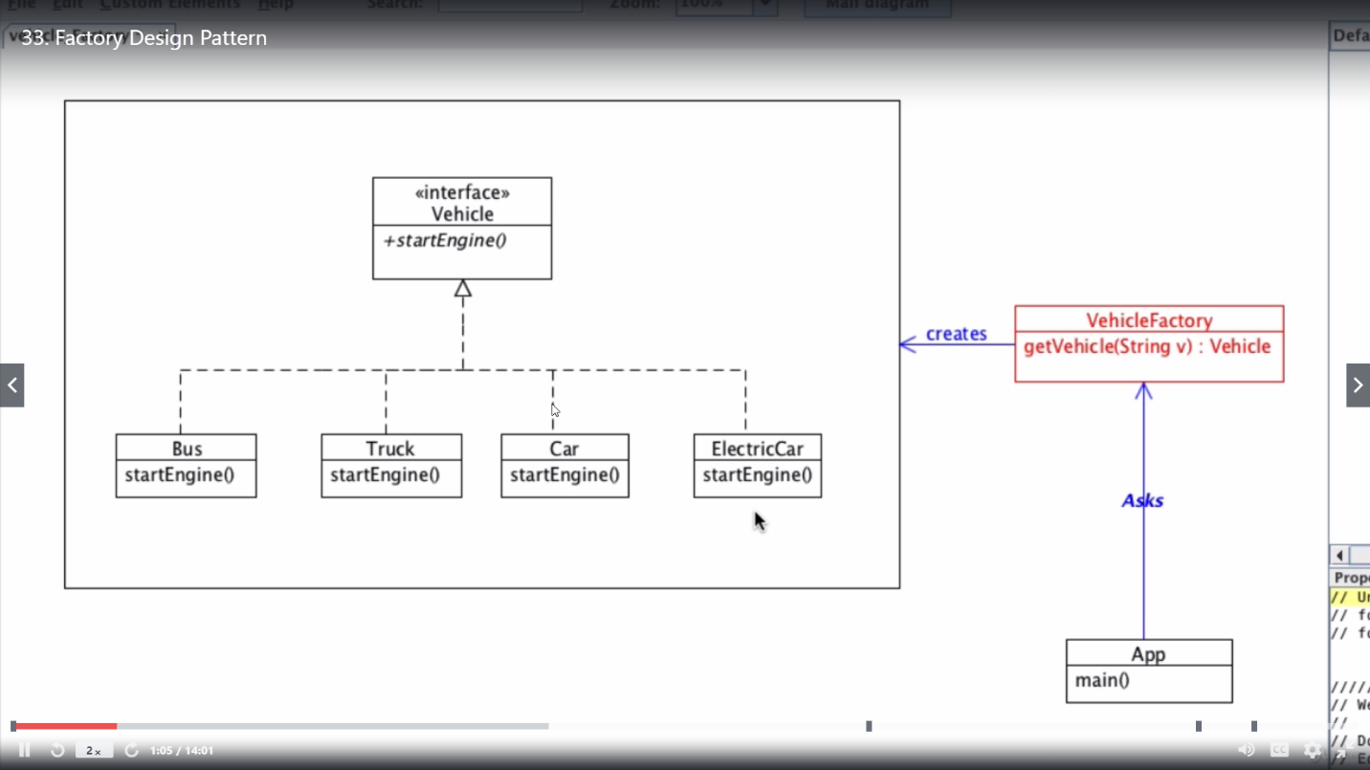

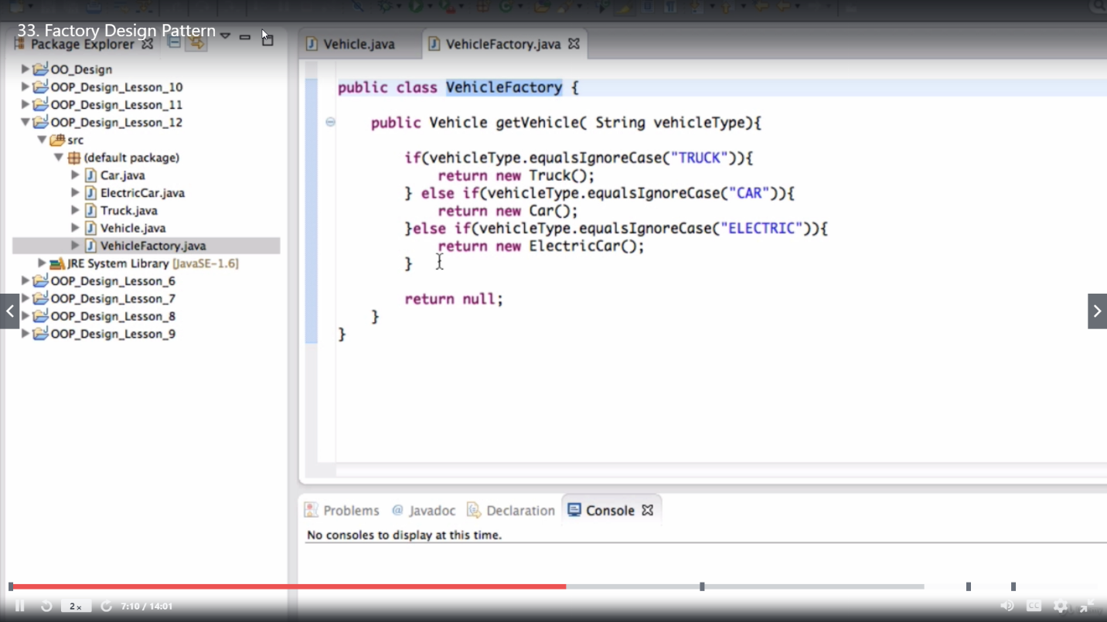

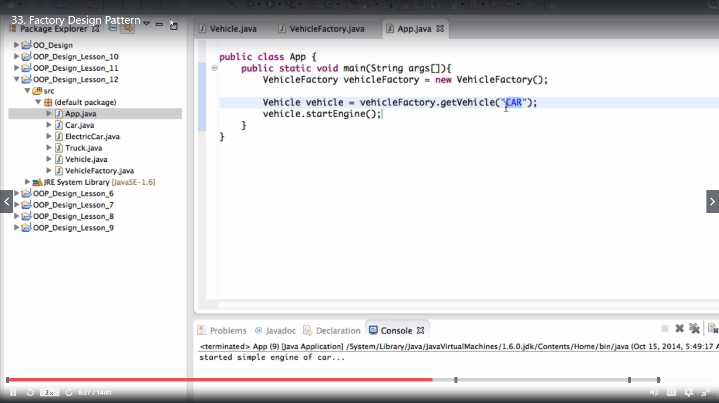

## Singleton Pattern

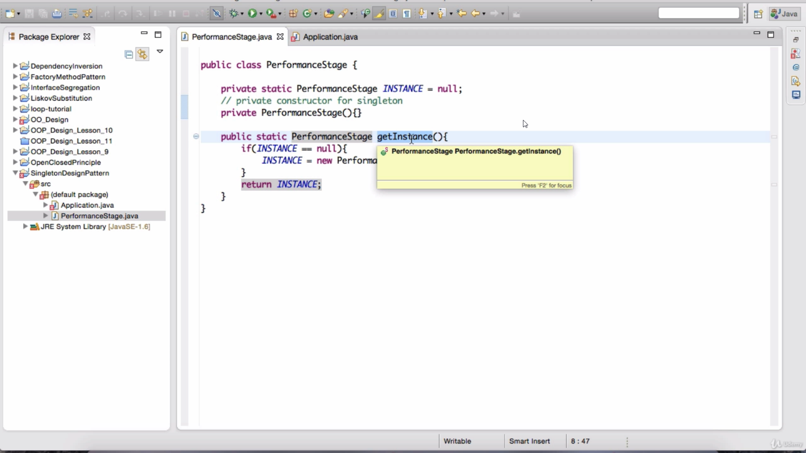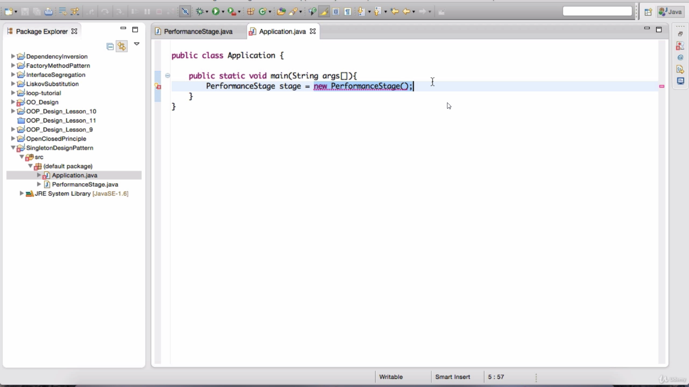

Use synchronized for thread safe, otherwise 2 thread may come same time and see instance=null and both create instance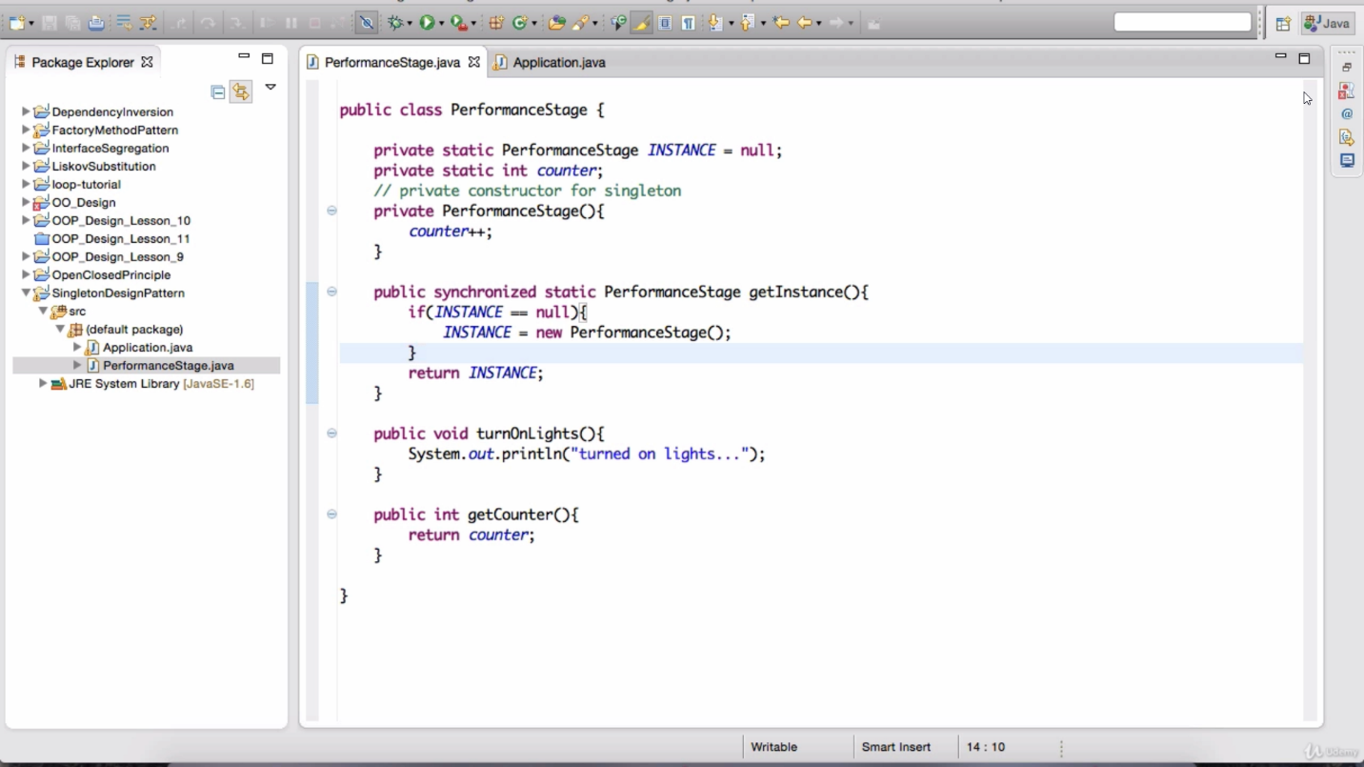

# DataStructure and algorithm

<https://github.com/rasmus4200/algorithms101>

# Multithreading

## Lifecycle of thread

A [thread](http://www.geeksforgeeks.org/multithreading-in-java/) in Java at any point of time exists in any one of the following states. A thread lies only in one of the shown states at any instant:

1. **New Thread:** When a new thread is created, it is in the new state. The thread has not yet started to run when thread is in this state. When a thread lies in the new state, it’s code is yet to be run and hasn’t started to execute.
2. **Runnable State:** A thread that is ready to run is moved to runnable state. In this state, a thread might actually be running or it might be ready run at any instant of time. It is the responsibility of the thread scheduler to give the thread, time to run.  
   A multi-threaded program allocates a fixed amount of time to each individual thread. Each and every thread runs for a short while and then pauses and relinquishes the CPU to another thread, so that other threads can get a chance to run. When this happens, all such threads that are ready to run, waiting for the CPU and the currently running thread lies in runnable state.
3. **Blocked/Waiting state:**When a thread is temporarily inactive, then it’s in one of the following states:
   * Blocked
   * Waiting

For example, when a thread is waiting for I/O to complete, it lies in the blocked state. It’s the responsibility of the thread scheduler to reactivate and schedule a blocked/waiting thread. A thread in this state cannot continue its execution any further until it is moved to runnable state. Any thread in these states does not consume any CPU cycle.

A thread is in the blocked state when it tries to access a protected section of code that is currently locked by some other thread. When the protected section is unlocked, the schedule picks one of the thread which is blocked for that section and moves it to the runnable state. Whereas, a thread is in the waiting state when it waits for another thread on a condition. When this condition is fulfilled, the scheduler is notified and the waiting thread is moved to runnable state.

If a currently running thread is moved to blocked/waiting state, another thread in the runnable state is scheduled by the thread scheduler to run. It is the responsibility of thread scheduler to determine which thread to run.

1. **Timed Waiting:** A thread lies in timed waiting state when it calls a method with a time out parameter. A thread lies in this state until the timeout is completed or until a notification is received. For example, when a thread calls sleep or a conditional wait, it is moved to a timed waiting state.
2. **Terminated State:** A thread terminates because of either of the following reasons:
   * Because it exists normally. This happens when the code of thread has entirely executed by the program.
   * Because there occurred some unusual erroneous event, like segmentation fault or an unhandled exception.

A thread that lies in a terminated state does no longer consumes any cycles of CPU.

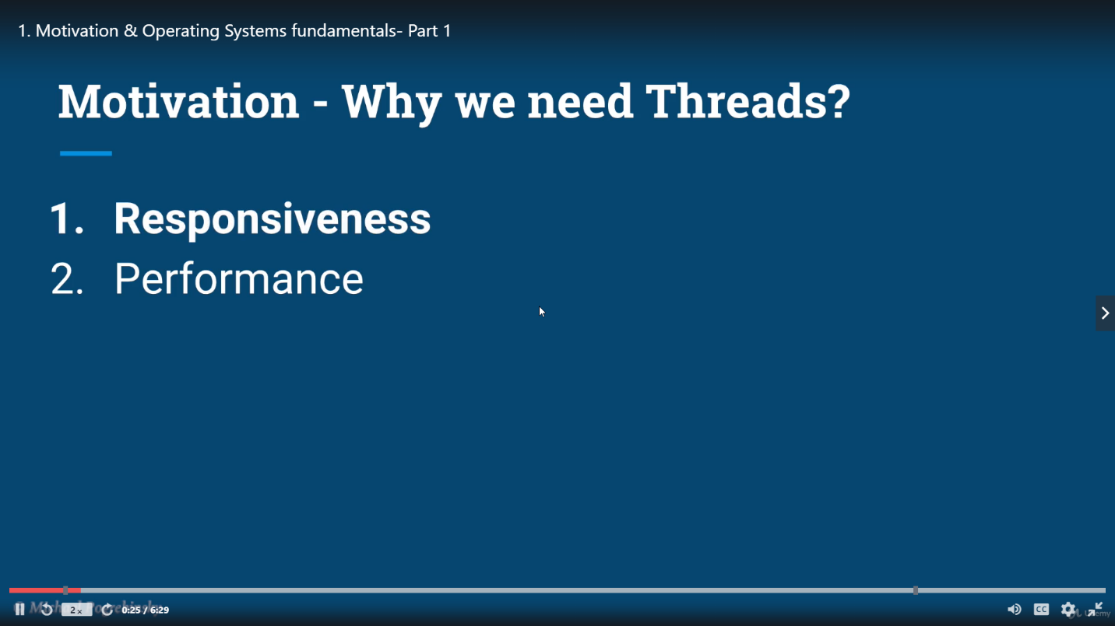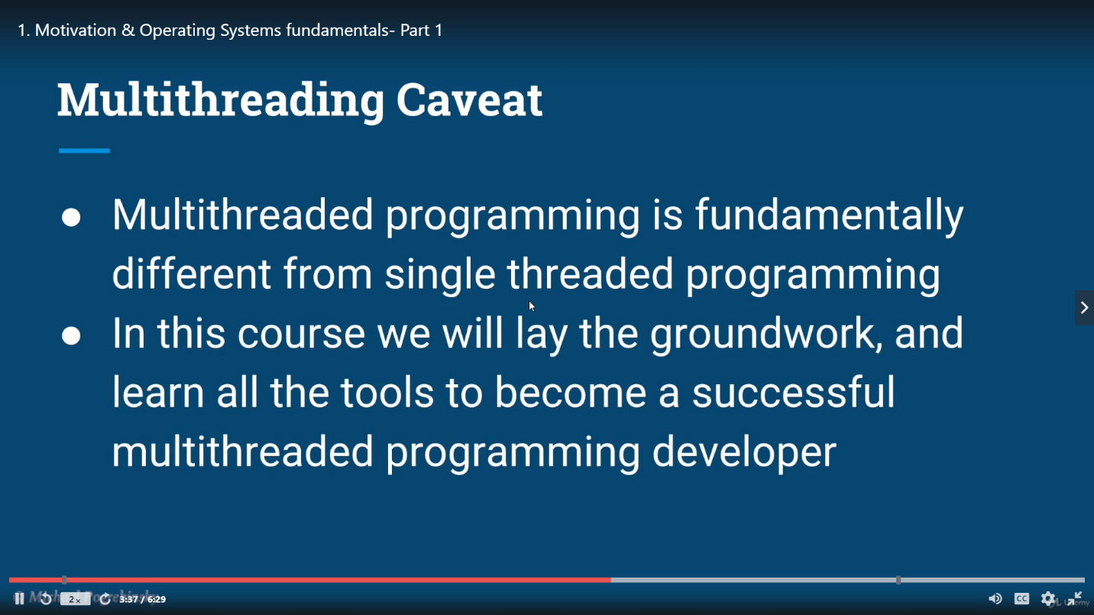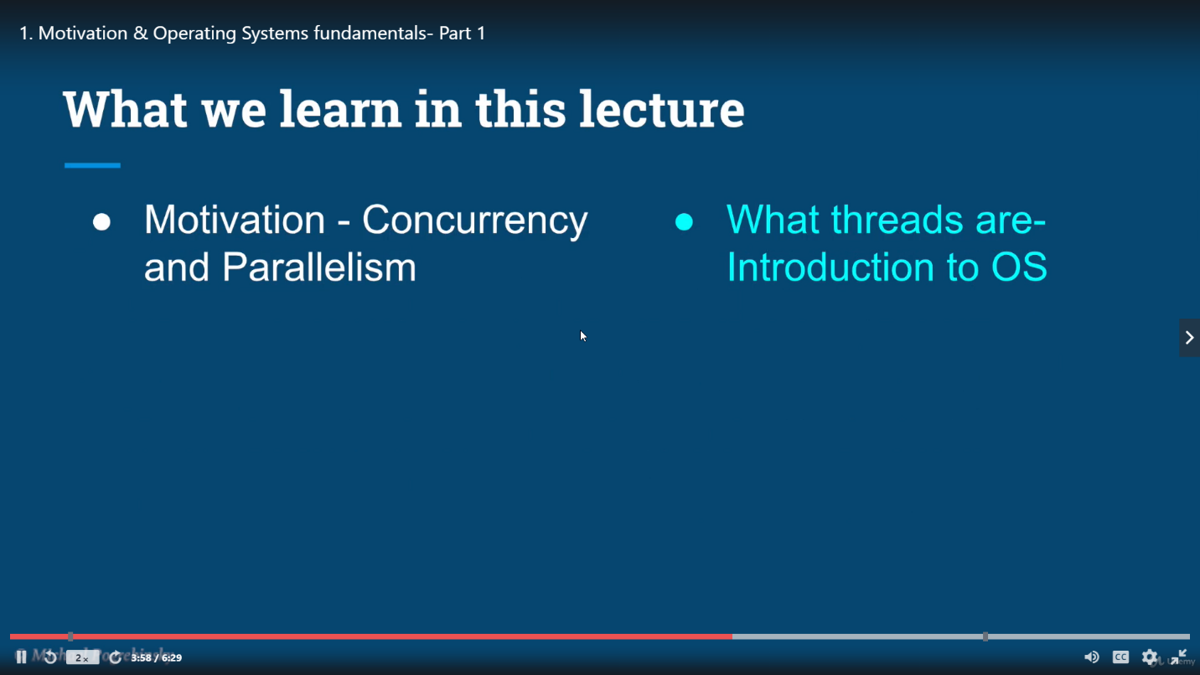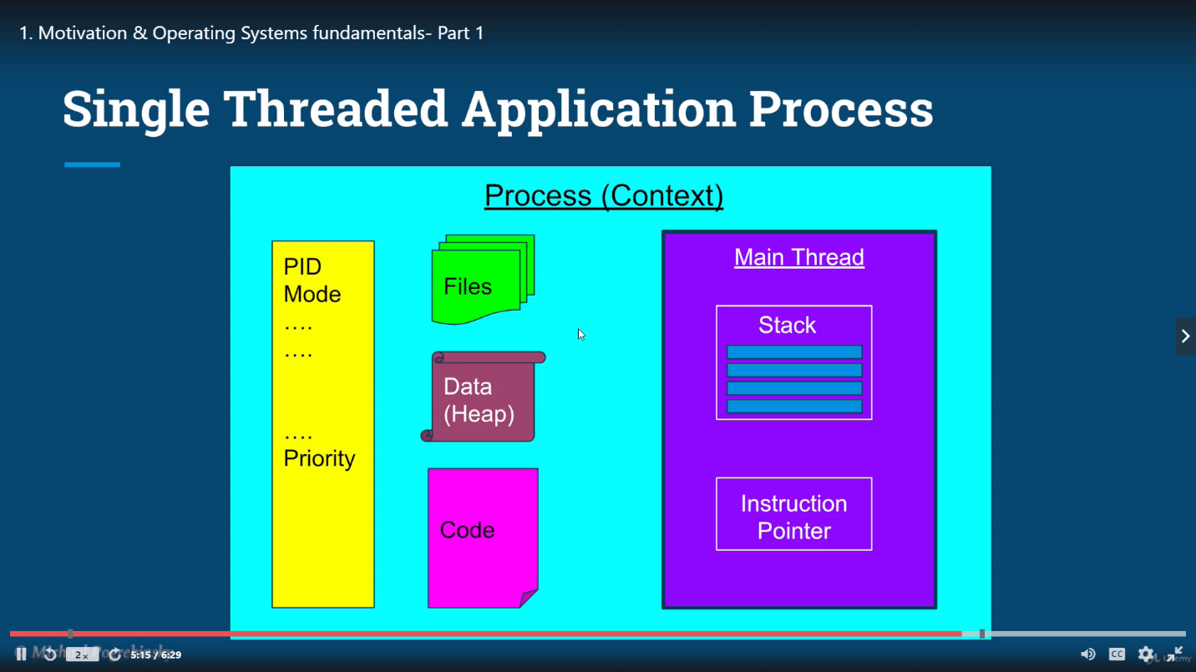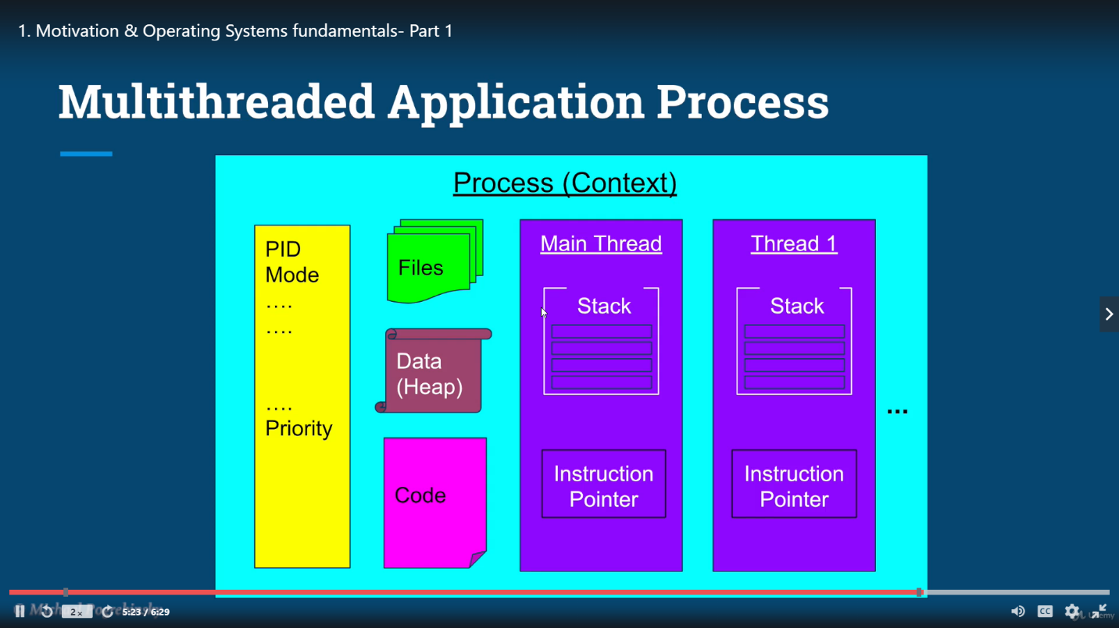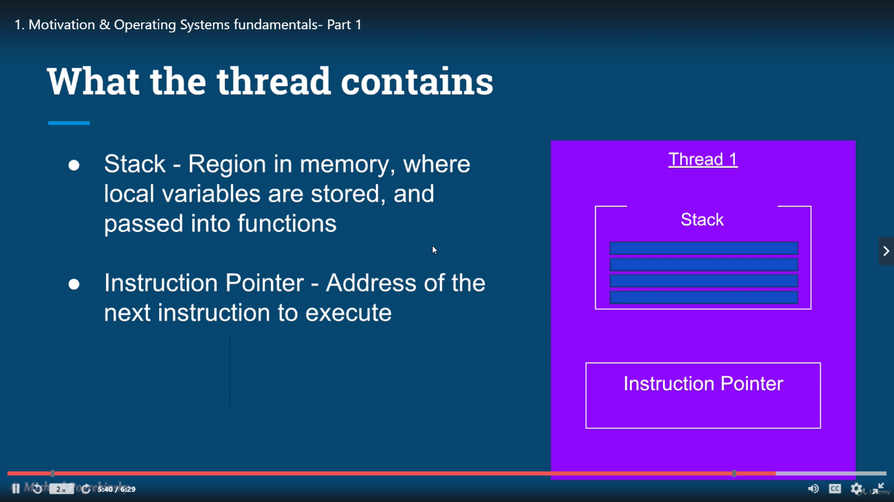

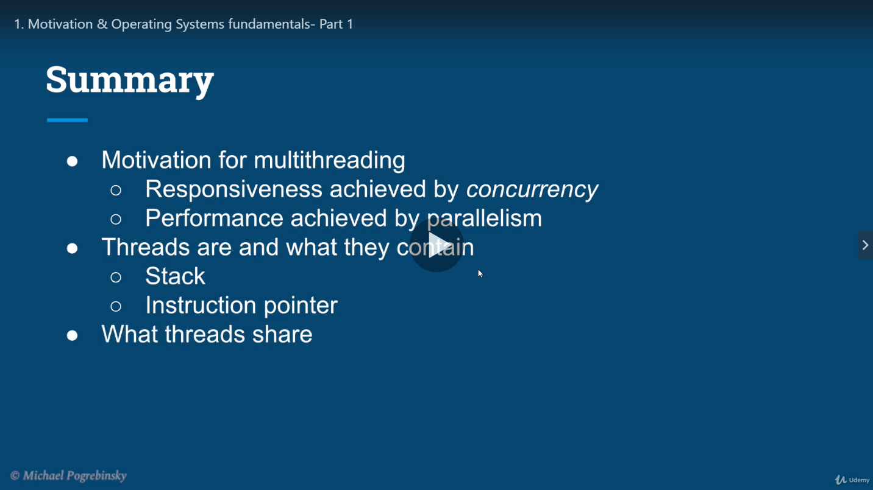

## Thread share Files,heap and code

## Context switch

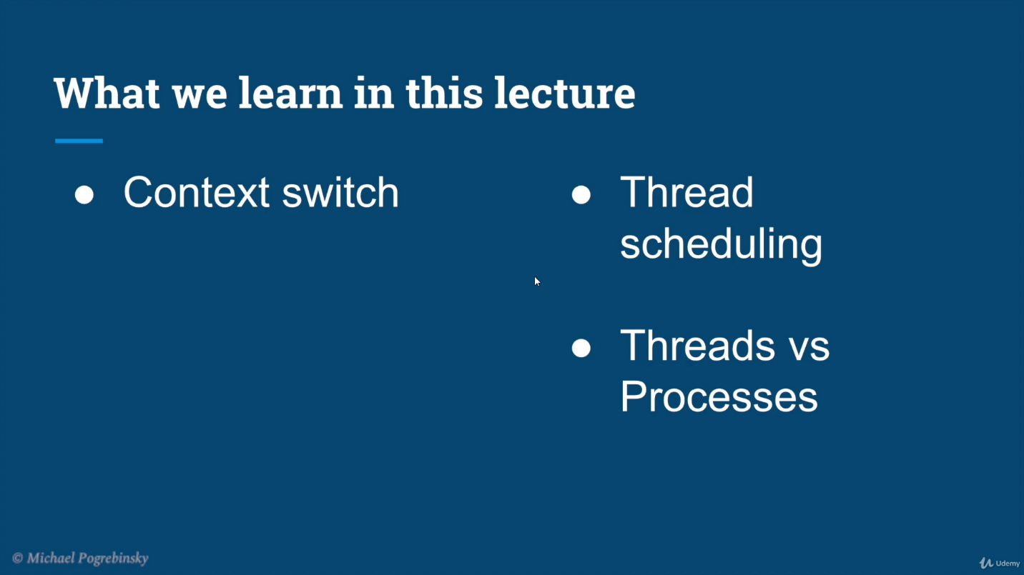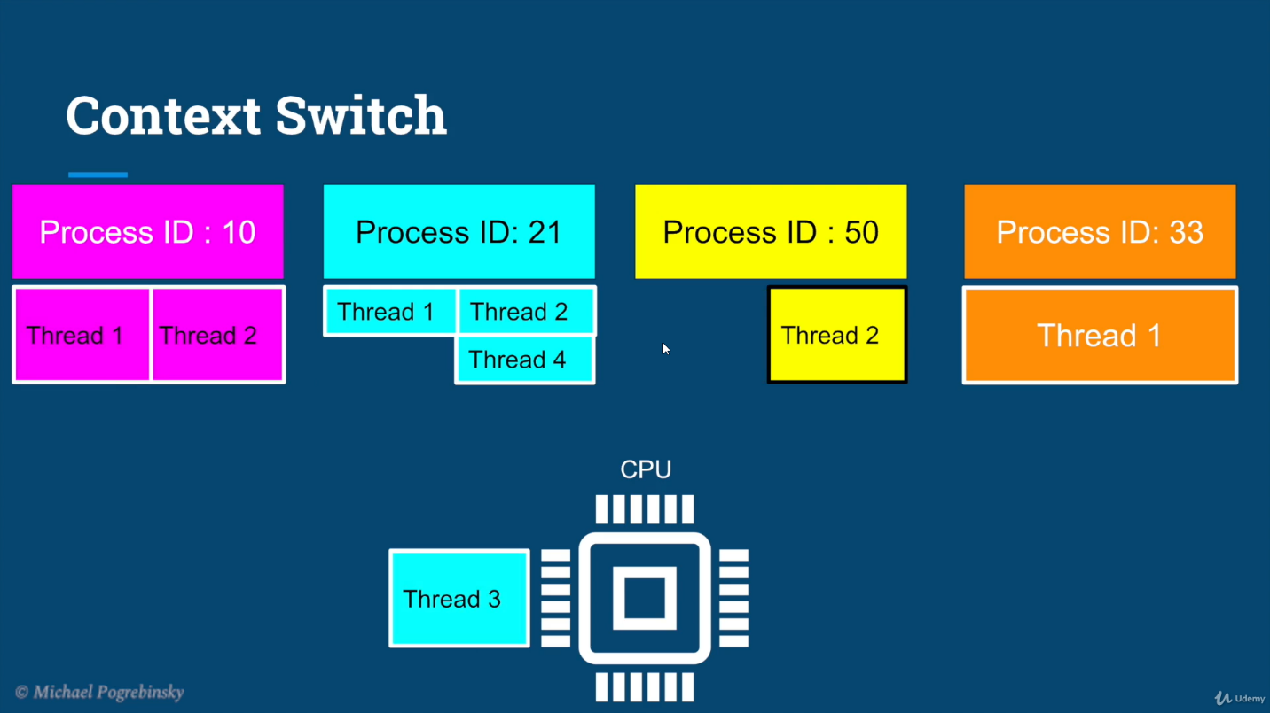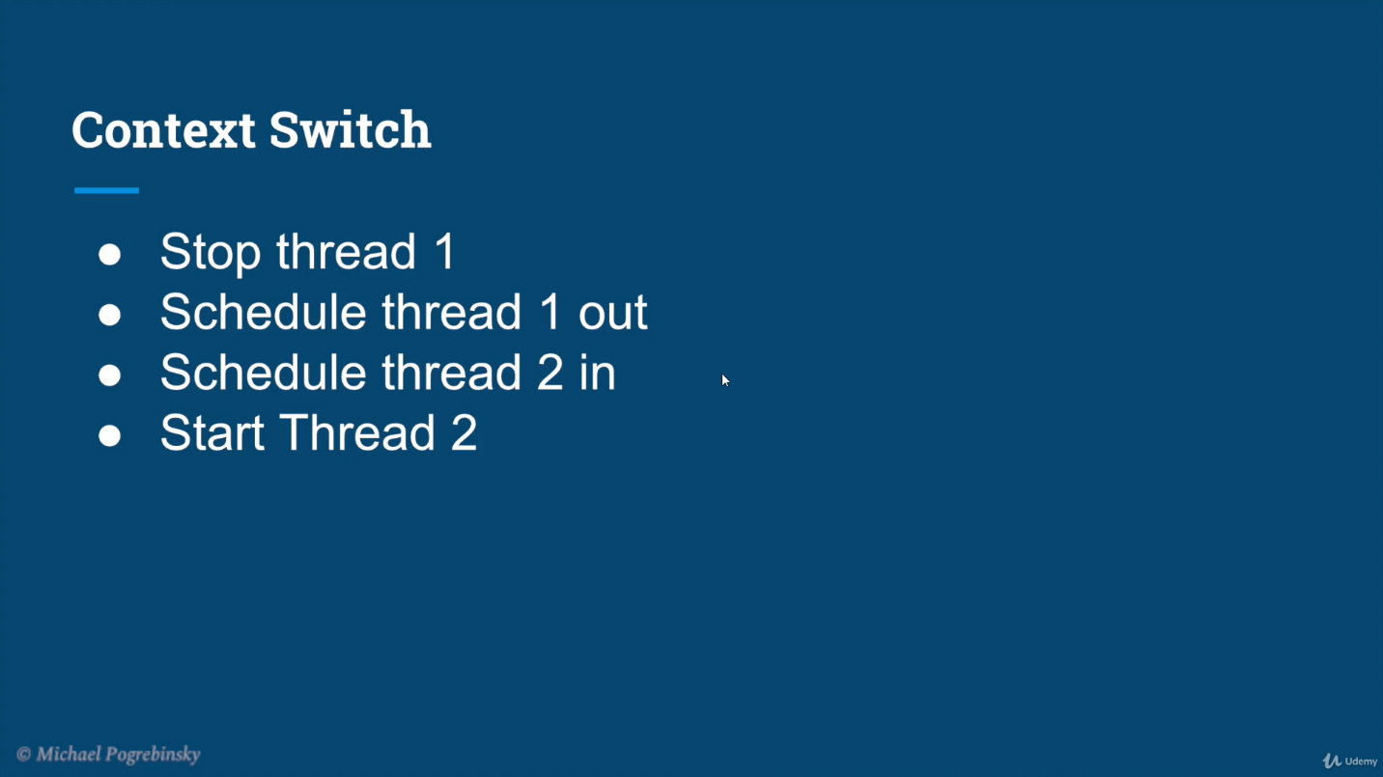

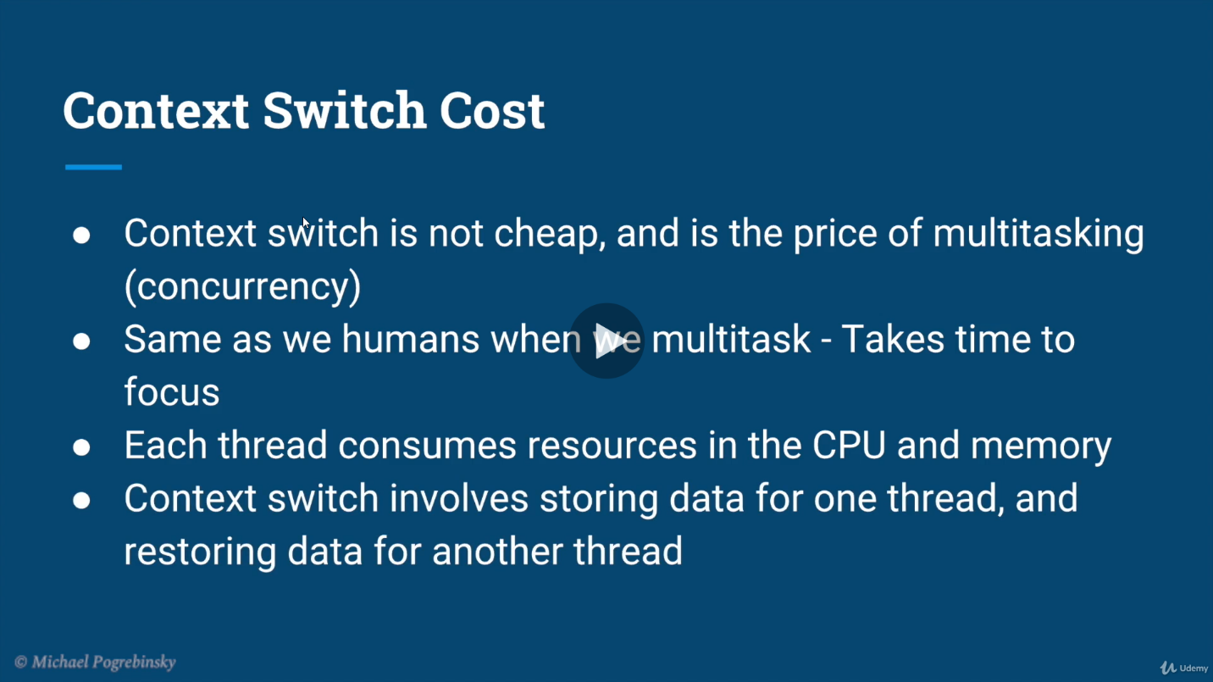

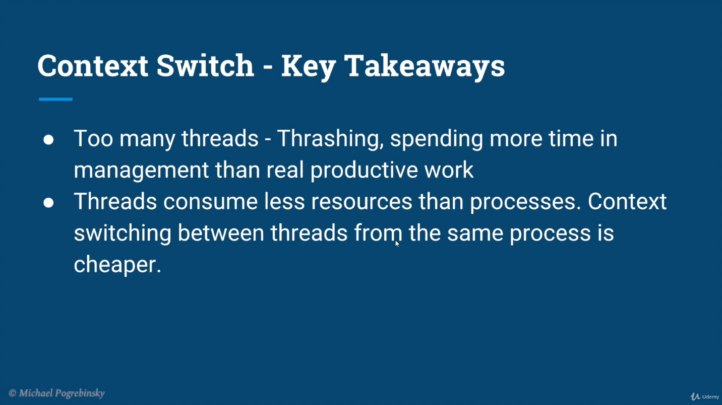

## Thread scheduling

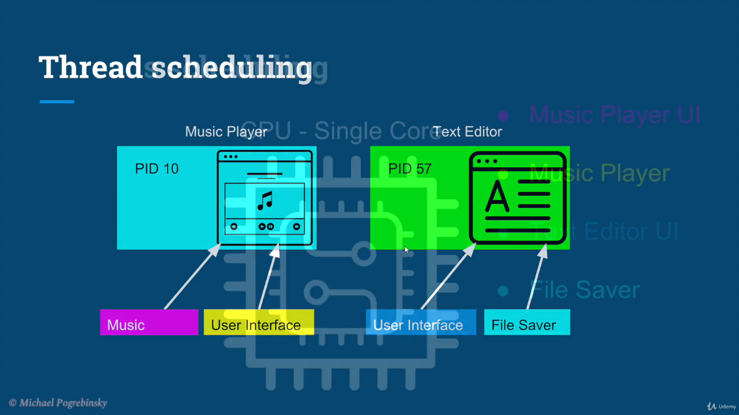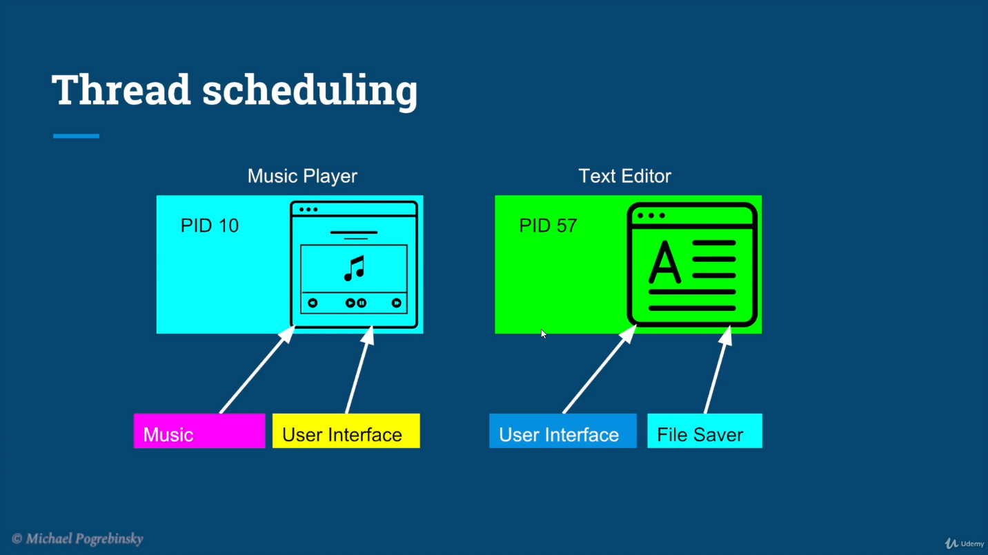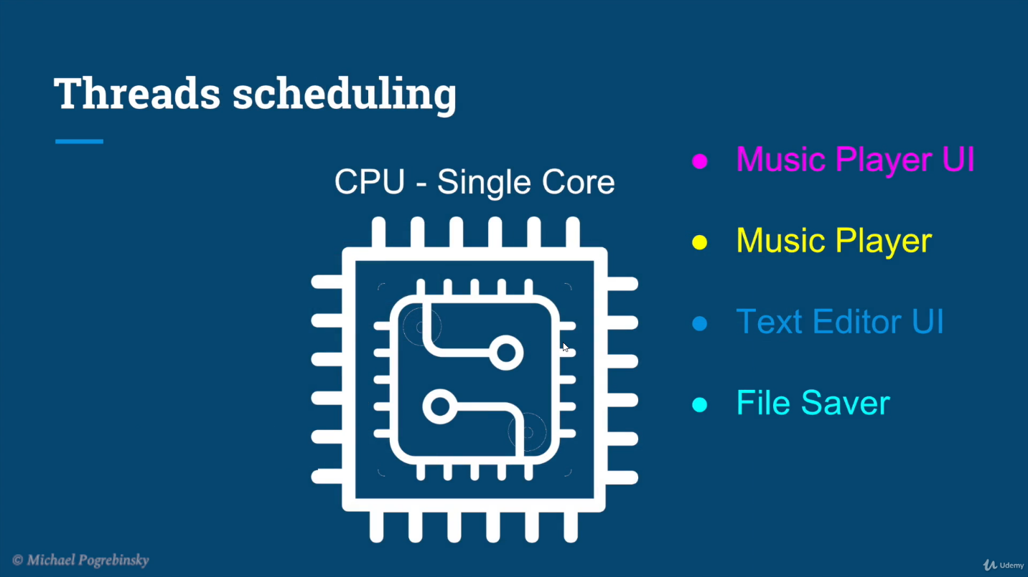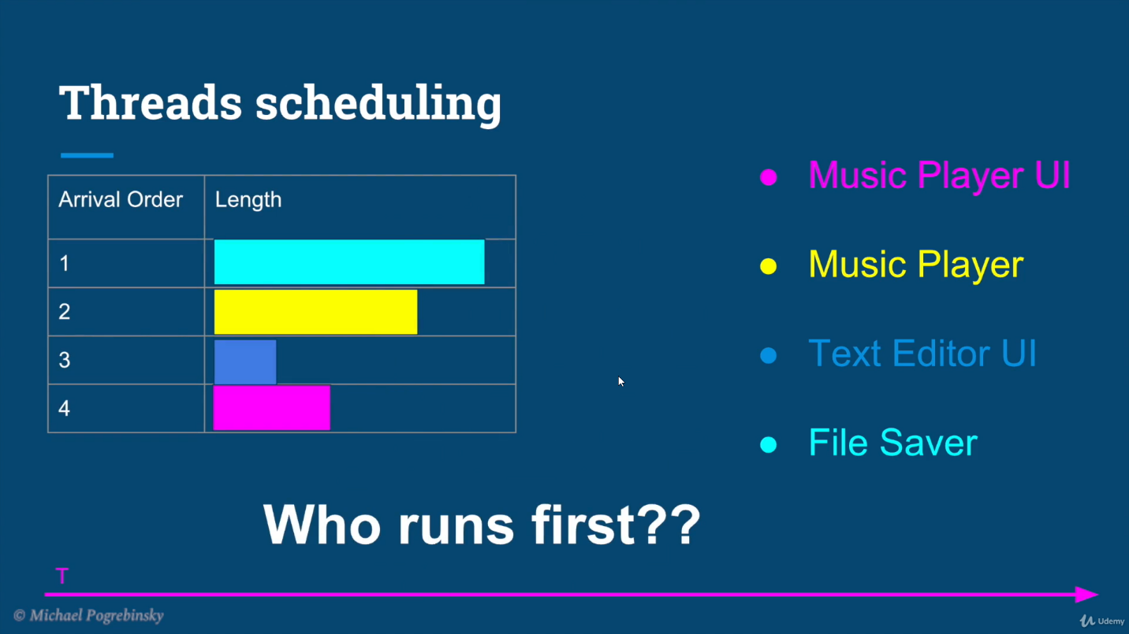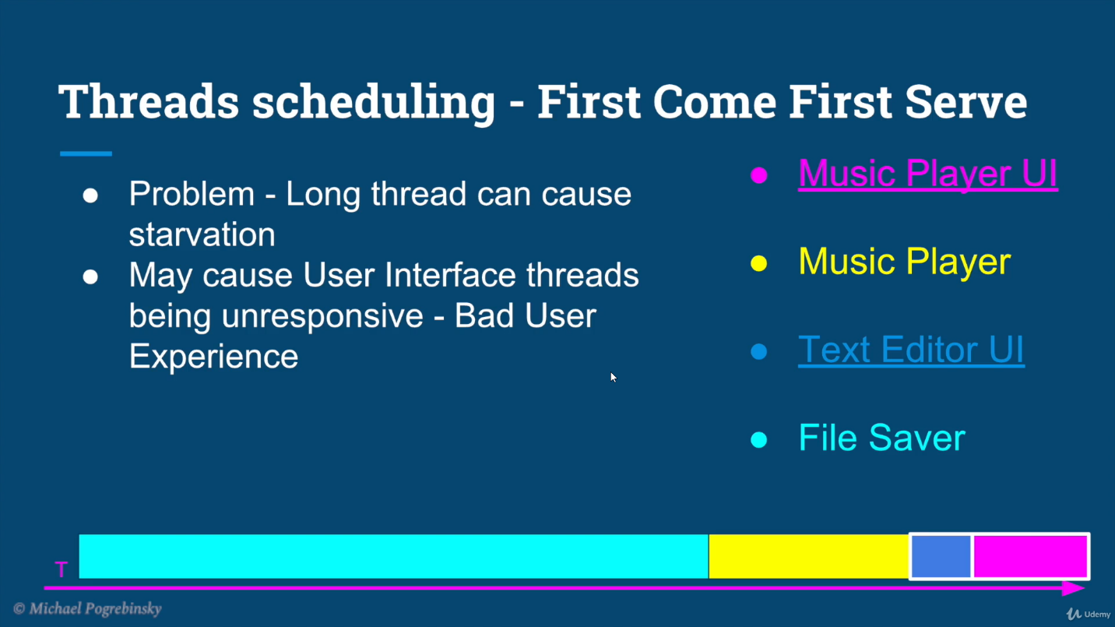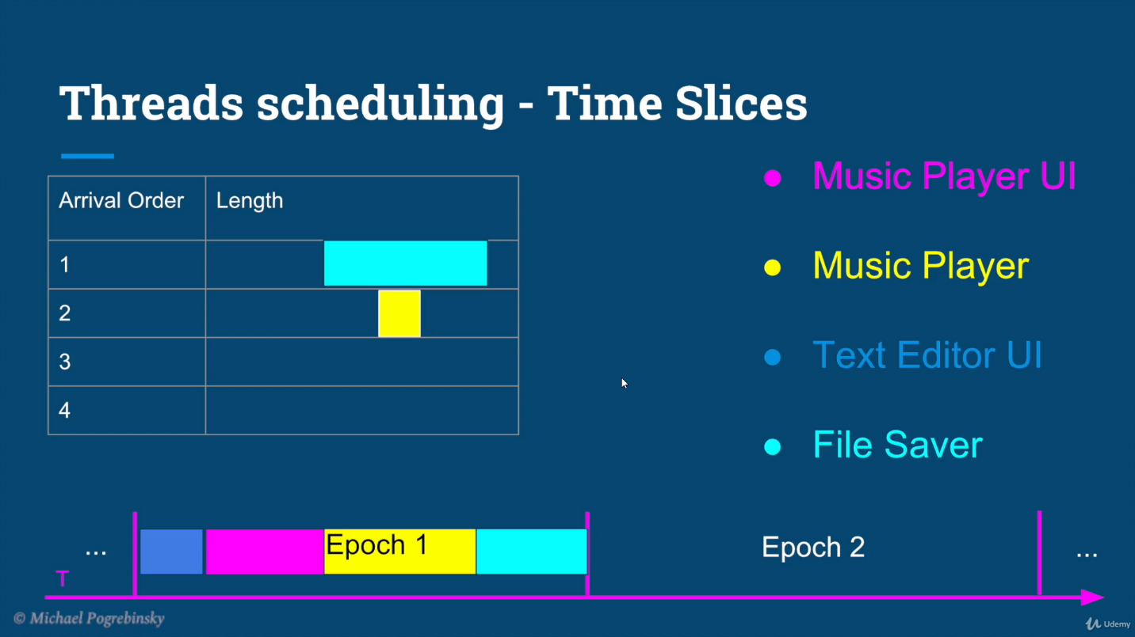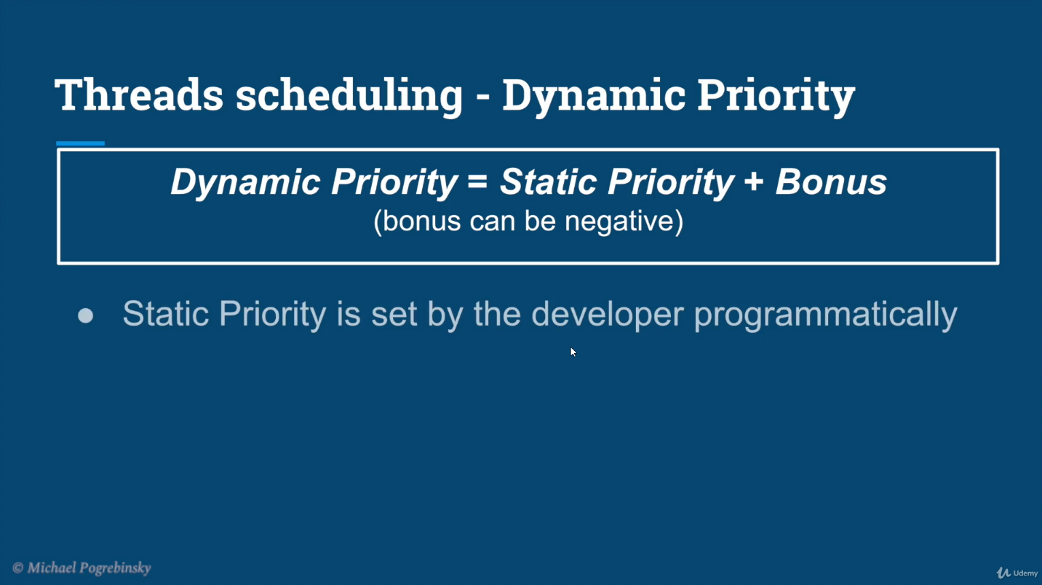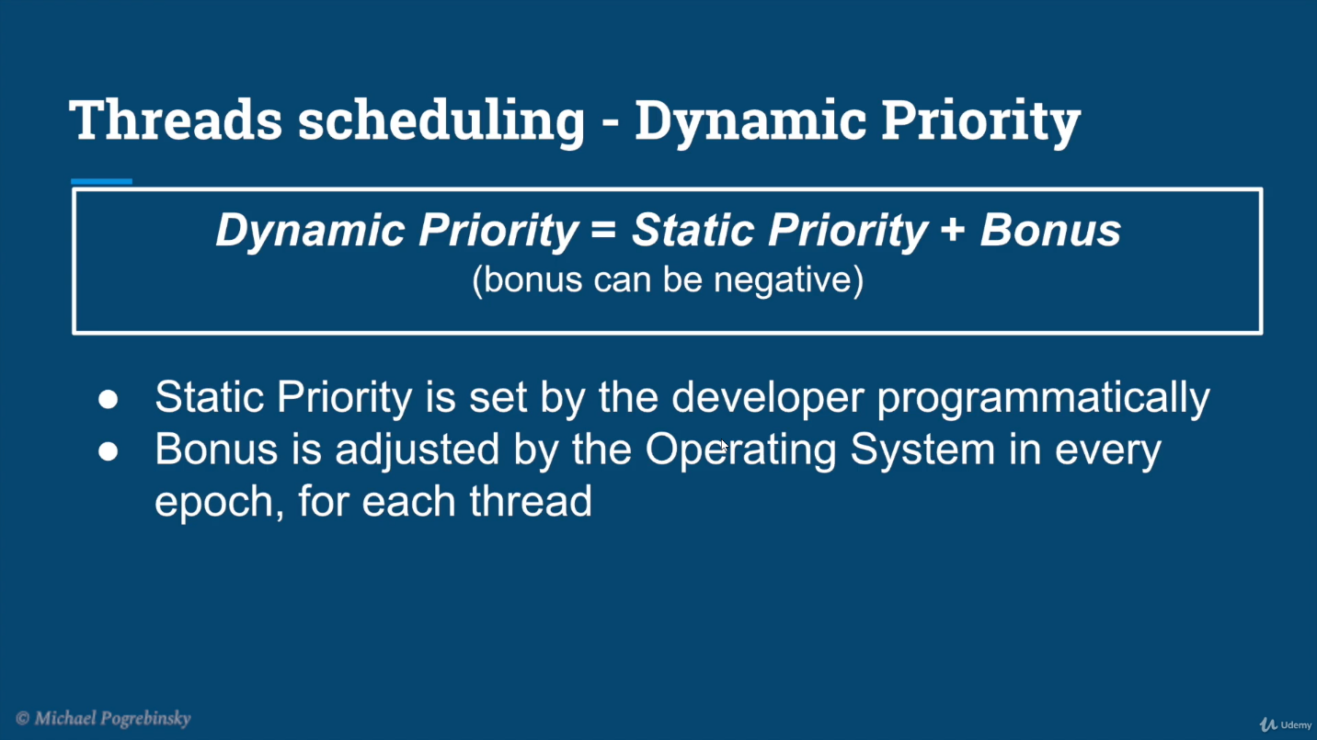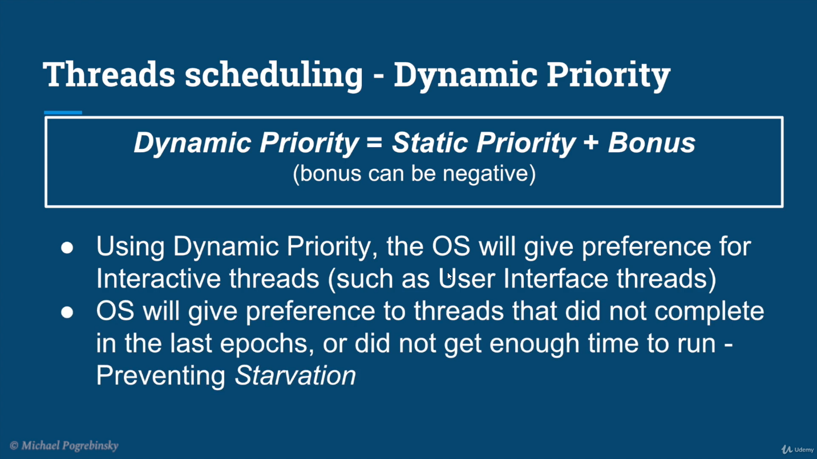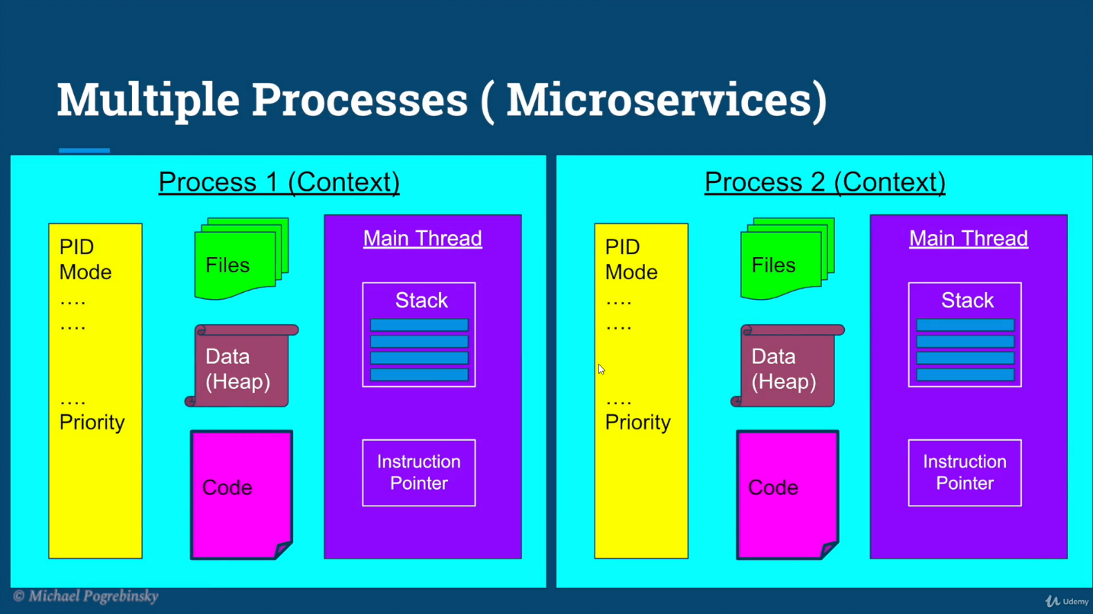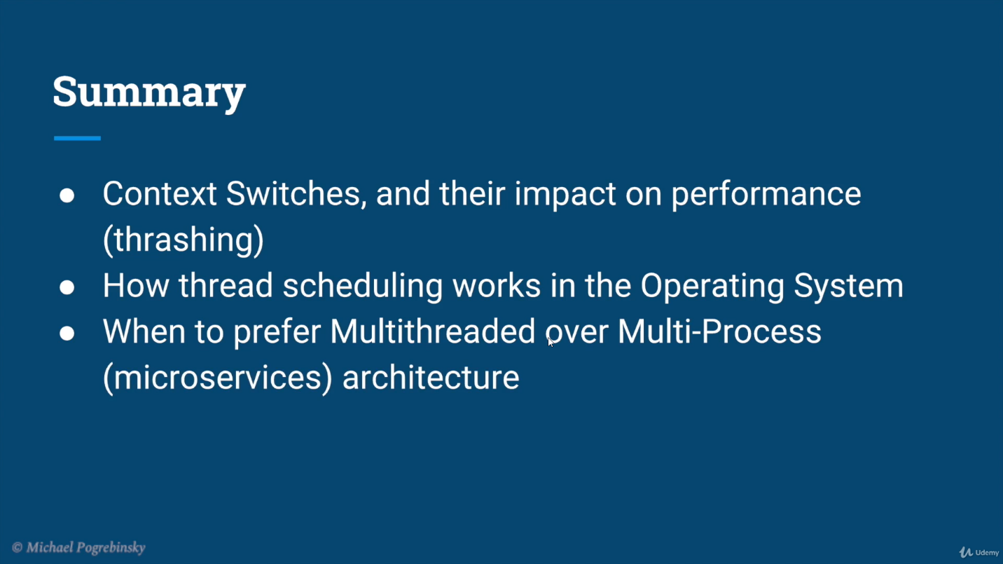

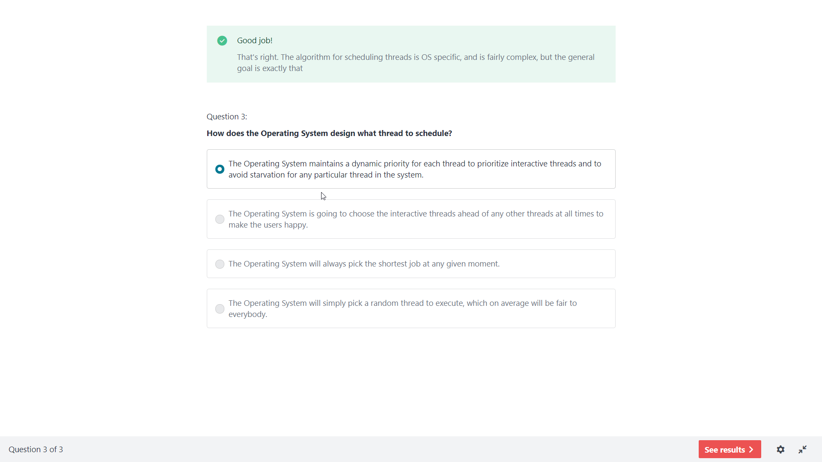

## How to create thread

There are two ways to create a thread:

1. By extending Thread class
2. By implementing Runnable interface.

**1)** Extending the java.lang.Thread class.

import java.util.concurrent.atomic.AtomicInteger;

class Counter extends Thread {

    AtomicInteger count = new AtomicInteger();

    // method where the thread execution will start

    public void run() {

        // logic to execute in a thread

        // e.g. performing a count task

        System.out.println(Thread.currentThread().getName() + " is executing..." + **count.incrementAndGet()**);

//atomic operation for count++

    }

    // let’s see how to start the threads

    public static void main(String[] args) {

        System.out.println(Thread.currentThread().getName() + " is executing..." );

        Counter counter = new Counter();

        Thread t1 = new Thread(counter);

        Thread t2 = new Thread(counter);

        t1.start(); // start the thread. This calls the run() method.

        t2.start(); // start the thread. This calls the run() method.

    }

}

**2)** Implementing the java.lang.Runnable interface.

import java.util.concurrent.atomic.AtomicInteger;

class Counter implements Runnable {

    AtomicInteger count = new AtomicInteger();

    // method where the thread execution will start

    public void run() {

        // logic to execute in a thread

        // e.g. performing a count task

        System.out.println(Thread.currentThread().getName() + " is executing..." + count.incrementAndGet());

    }

    // let’s see how to start the threads

    public static void main(String[] args) {

        System.out.println(Thread.currentThread().getName() + " is executing..." );

        Counter counter = new Counter();

        Thread t1 = new Thread(counter);

        Thread t2 = new Thread(counter);

        t1.start(); // start the thread. This calls the run() method.

        t2.start(); // start the thread. This calls the run() method.

    }

}

**3)** Implementing the java.util.concurrent.Callable interface with the java.util.concurrent.Executor framework to pool the threads. The java.util.concurrent package was added in Java 5. [ [7 basic Java Executor framework Interview Q&As with Future & CompletableFuture](https://www.java-success.com/08-%e2%99%a6-java-executor-framework-interview-questions-answers/) ]

import java.util.concurrent.Callable;

import java.util.concurrent.ExecutionException;

import java.util.concurrent.ExecutorService;

import java.util.concurrent.Executors;

import java.util.concurrent.Future;

import java.util.concurrent.atomic.AtomicInteger;

class Counter implements Callable {

    private static final int THREAD_POOL_SIZE = 2;

    private AtomicInteger count = new AtomicInteger();

    // method where the thread execution takes place

    public String call() {

        return Thread.currentThread().getName() + " executing ..." + count.incrementAndGet(); //Consumer

    }

    public static void main(String[] args) throws InterruptedException,

            ExecutionException {

        // create a pool of 2 threads

        ExecutorService executor = Executors

                .newFixedThreadPool(THREAD_POOL_SIZE);

        Counter counter = new Counter();

        Future future1 = executor.submit(counter);    //Producer

        Future future2 = executor.submit(counter);    //Producer

        System.out.println(Thread.currentThread().getName() + " executing ...");

        //asynchronously get from the worker threads

        System.out.println(future1.get());

        System.out.println(future2.get());

    }

}

**4)** Using the Fork/Join Pool. [Java 7 fork and join tutorial with a diagram and an example](https://www.java-success.com/java-7-fork-join-tutorial-diagram-example/).

**5)** **Java 8** – BaseStream.parallel() – Use this for low CPU intensive tasks. All parallel streams use common **fork-join** thread pool, and if you submit a long-running task, you effectively block all threads in the pool.

Employee[] employees = { new Employee("John", 45000), new Employee("Peter", 65000.00), new Employee("Sam", 85000.00)};

List inputList = Arrays.asList(employees);

List newMutatedList = inputList.stream().parallel()

                                         .map(x -> new Employee(x.getName(), x.getSalary() * 1.05)) // returns a new list

                                         .collect(Collectors.toList());

System.out.println(inputList); //[Employee [name=John, salary=45000.0], Employee [name=Peter, salary=65000.0], Employee [name=Sam, salary=85000.0]]

System.out.println(newMutatedList); //[Employee [name=John, salary=47250.0], Employee [name=Peter, salary=68250.0], Employee [name=Sam, salary=89250.0]]

**6)** The actor model, which is also known as Reactive Programming using frameworks like **Akka**. [Simple Akka tutorial in Java step by step](https://www.java-success.com/01-simple-akka-tutorial-java-step-step/)

## Thread class:

|  |
| --- |
| Thread class provide constructors and methods to create and perform operations on a thread.Thread class extends Object class and implements Runnable interface. |

## Commonly used Constructors of Thread class:

|  |
| --- |
| * Thread() * Thread(String name) * Thread(Runnable r) * Thread(Runnable r,String name) |

## Commonly used methods of Thread class

|  |
| --- |
| 1. **public void run():**is used to perform action for a thread. 2. **public void start():**starts the execution of the thread.JVM calls the run() method on the thread. 3. **public void sleep(long miliseconds):**Causes the currently executing thread to sleep (temporarily cease execution) for the specified number of milliseconds. 4. **public void join():**waits for a thread to die. 5. **public void join(long miliseconds):**waits for a thread to die for the specified miliseconds. 6. **public int getPriority():**returns the priority of the thread. 7. **public int setPriority(int priority):**changes the priority of the thread. 8. **public String getName():**returns the name of the thread. 9. **public void setName(String name):**changes the name of the thread. 10. **public Thread currentThread():**returns the reference of currently executing thread. 11. **public int getId():**returns the id of the thread. 12. **public Thread.State getState():**returns the state of the thread. 13. **public boolean isAlive():**tests if the thread is alive. 14. **public void yield():**causes the currently executing thread object to temporarily pause and allow other threads to execute. 15. **public void suspend():**is used to suspend the thread(depricated). 16. **public void resume():**is used to resume the suspended thread(depricated). 17. **public void stop():**is used to stop the thread(depricated). 18. **public boolean isDaemon():**tests if the thread is a daemon thread. 19. **public void setDaemon(boolean b):**marks the thread as daemon or user thread. 20. **public void interrupt():**interrupts the thread. 21. **public boolean isInterrupted():**tests if the thread has been interrupted. 22. **public static boolean interrupted():**tests if the current thread has been interrupted. |
|  |

## Program to control main thread and setting priority

* Thread with highest priority will get execution chance prior to other threads. Suppose there are 3 threads t1, t2 and t3 with priorities 4, 6 and 1. So, thread t2 will execute first based on maximum priority 6 after that t1 will execute and then t3.
* Default priority for main thread is always 5, it can be changed later. Default priority for all other threads depends on the priority of parent thread.

// Java program to control the Main Thread

public class Test extends Thread

{

    public static void main(String[] args)

    {

        // getting reference to Main thread

        Thread t = Thread.currentThread();

        // getting name of Main thread

        System.out.println("Current thread: " + t.getName());

        // changing the name of Main thread

        t.setName("Geeks");

        System.out.println("After name change: " + t.getName());

        // getting priority of Main thread

        System.out.println("Main thread priority: "+ t.getPriority());

        // setting priority of Main thread to MAX(10)

        t.setPriority(MAX_PRIORITY);

        System.out.println("Main thread new priority: "+ t.getPriority());

        for (int i = 0; i < 5; i++)

        {

            System.out.println("Main thread");

        }

        // Main thread creating a child thread

        ChildThread ct = new ChildThread();

        // getting priority of child thread

        // which will be inherited from Main thread

        // as it is created by Main thread

        System.out.println("Child thread priority: "+ ct.getPriority());

        // setting priority of Main thread to MIN(1)

        ct.setPriority(MIN_PRIORITY);

        System.out.println("Child thread new priority: "+ ct.getPriority());

        // starting child thread

        ct.start();

    }

}

// Child Thread class

class ChildThread extends Thread

{

    @Override

    public void run()

    {

        for (int i = 0; i < 5; i++)

        {

            System.out.println("Child thread");

        }

    }

}

Output

Current thread: main

After name change: Geeks

Main thread priority: 5

Main thread new priority: 10

Main thread

Main thread

Main thread

Main thread

Main thread

Child thread priority: 10

Child thread new priority: 1

Child thread

Child thread

Child thread

Child thread

Child thread

# Thread termination or Interruption

thread.setDaemon(true);

//setting this as true will terminate all worker thread once main thread is completed

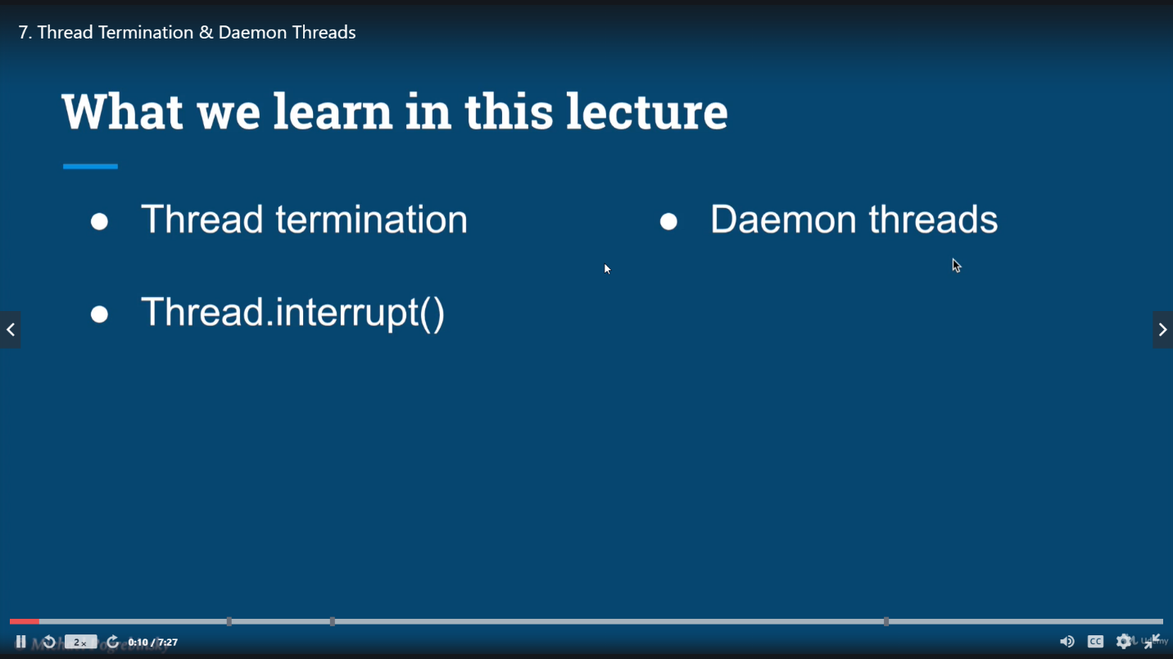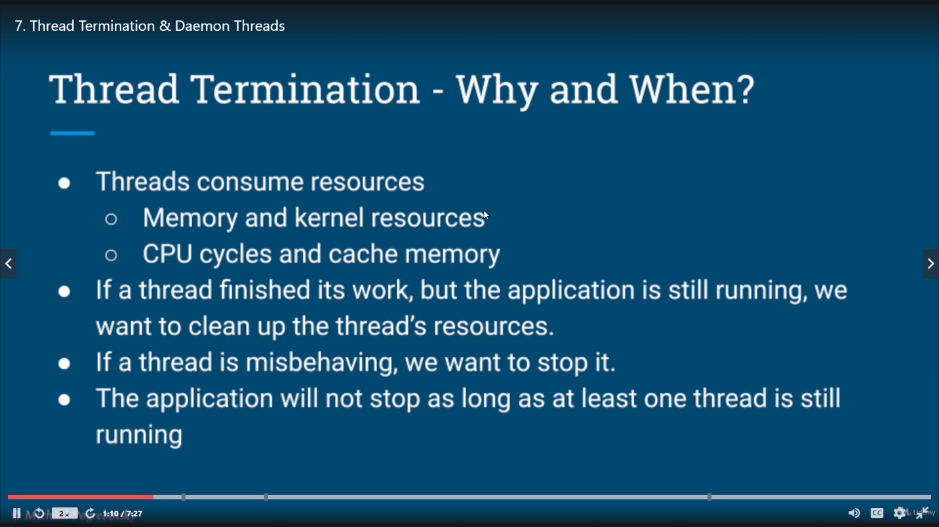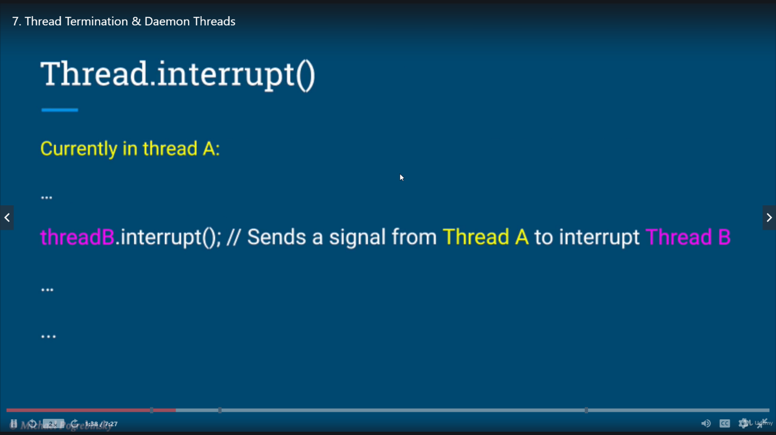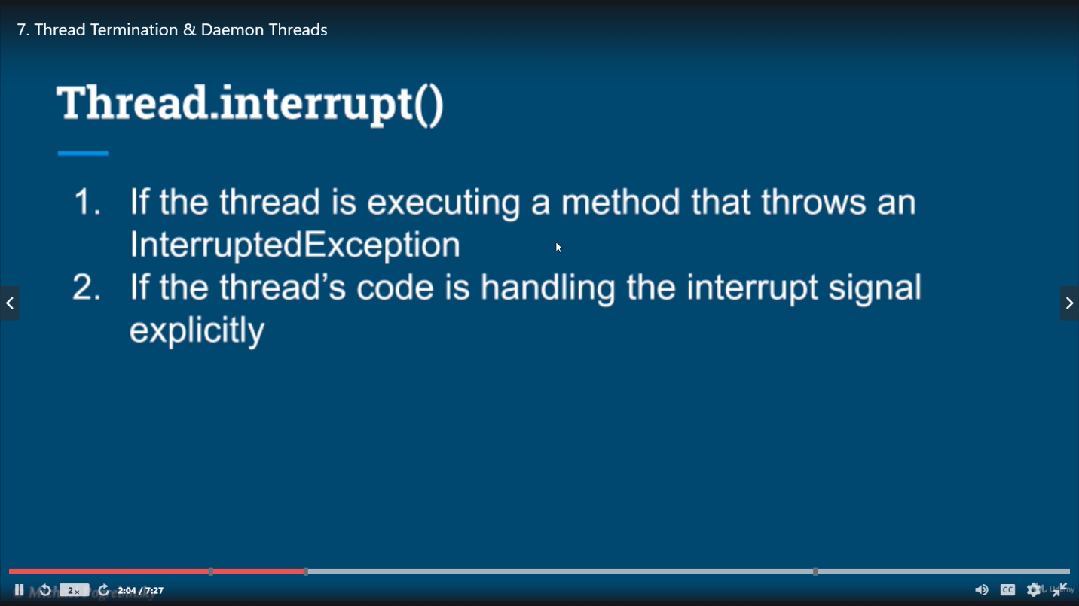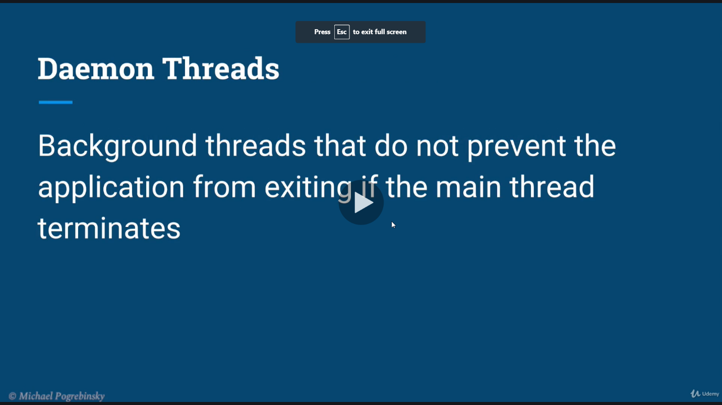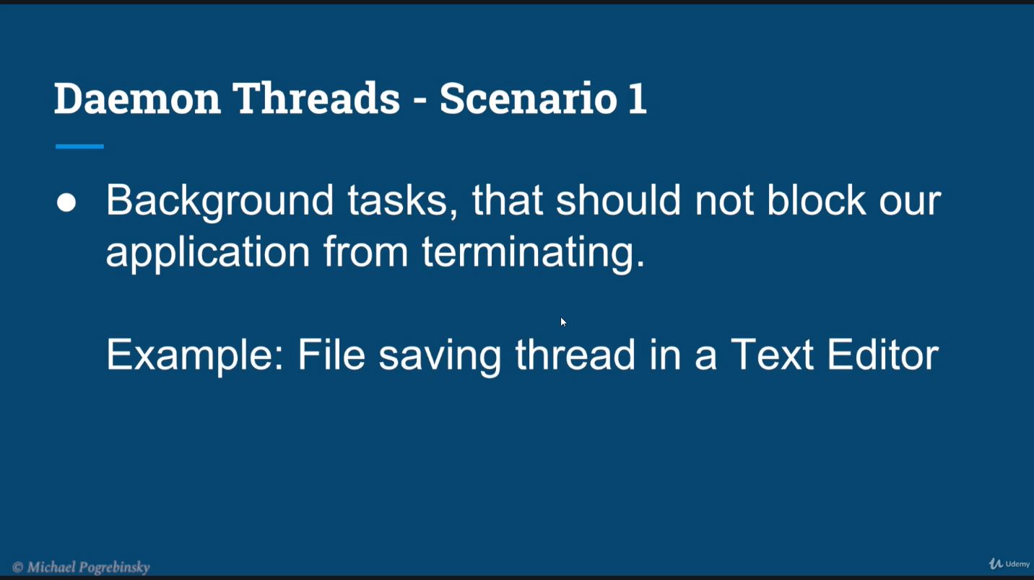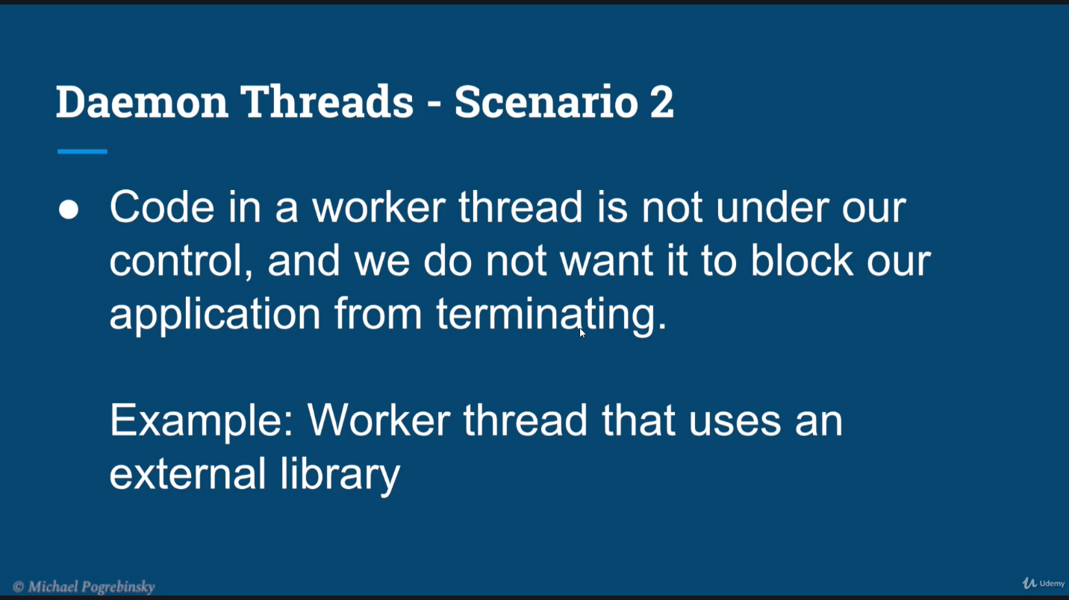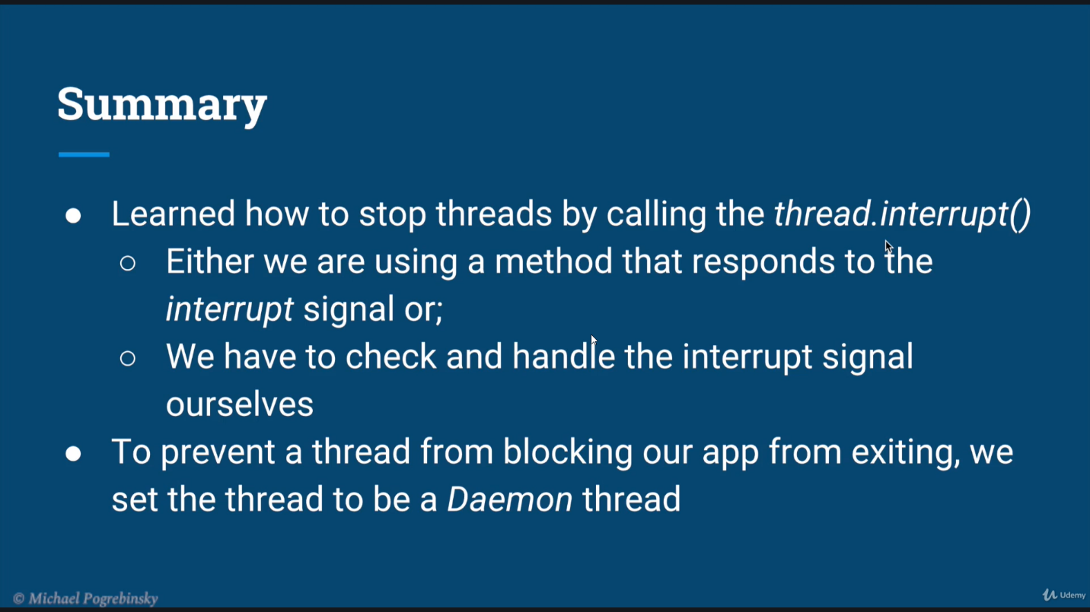

### Thread.join()

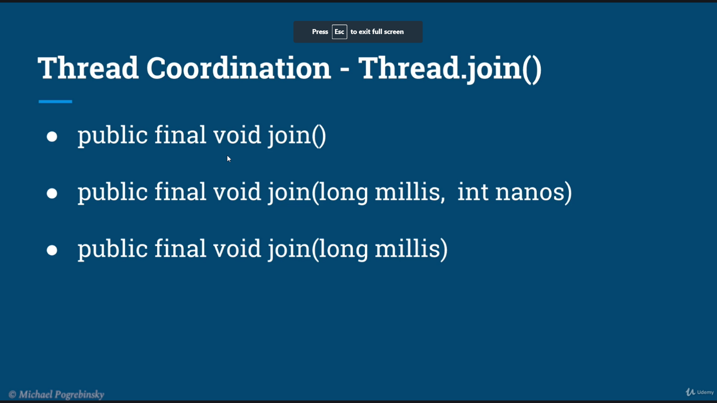

## Thread Performance optimization

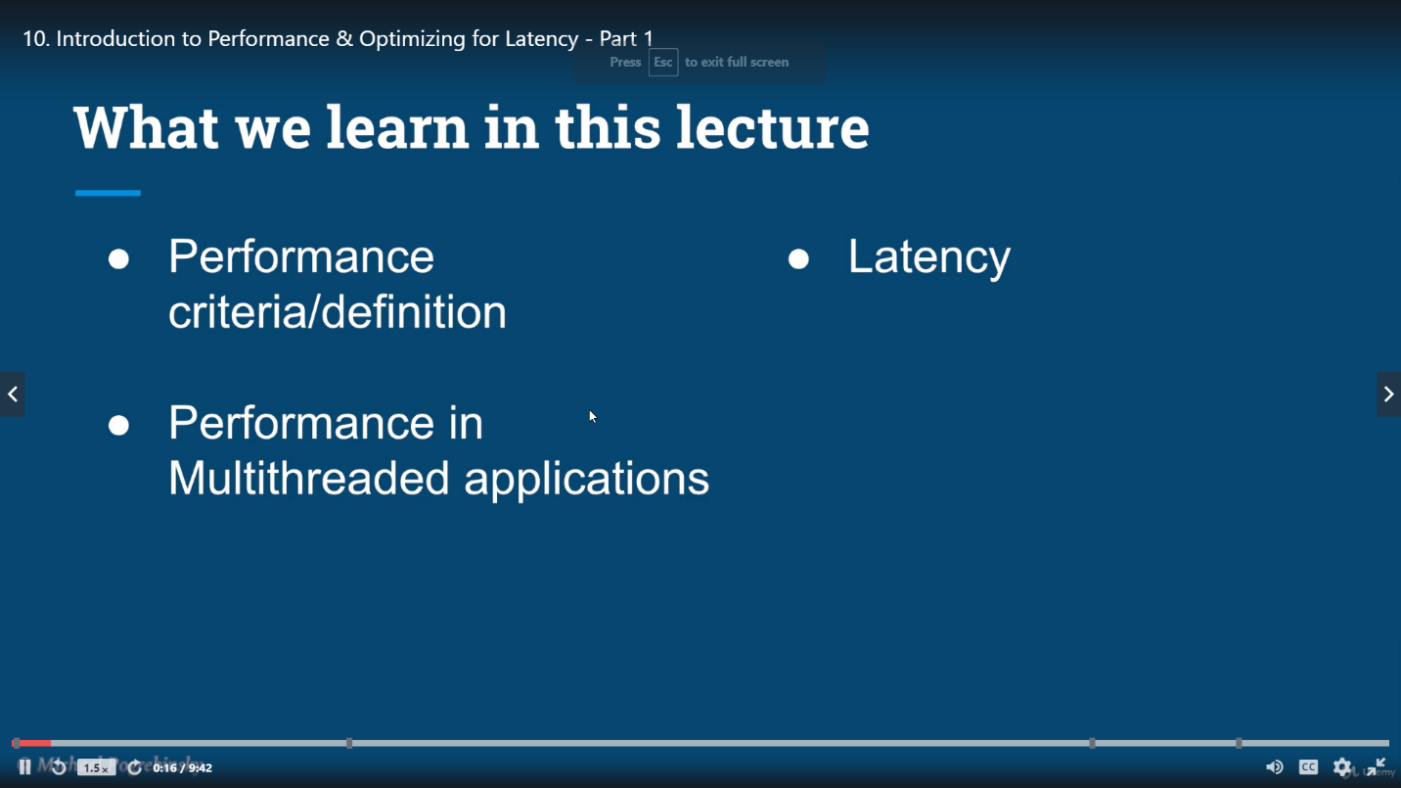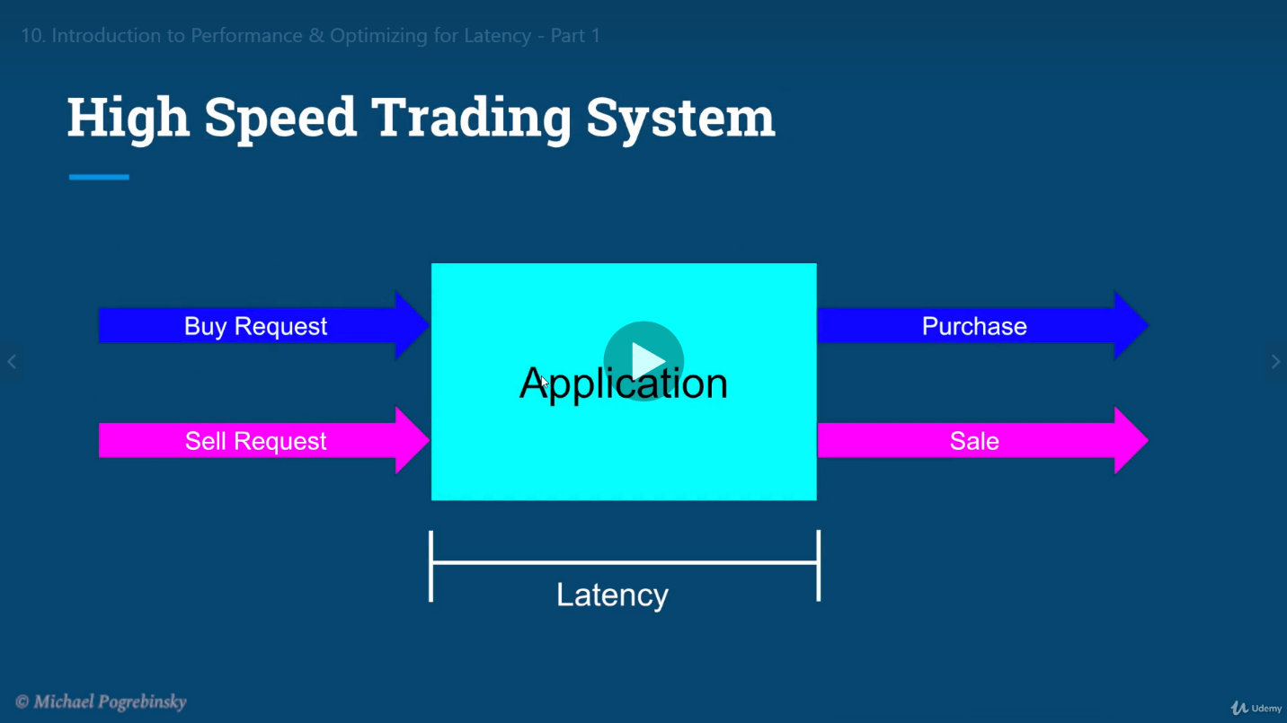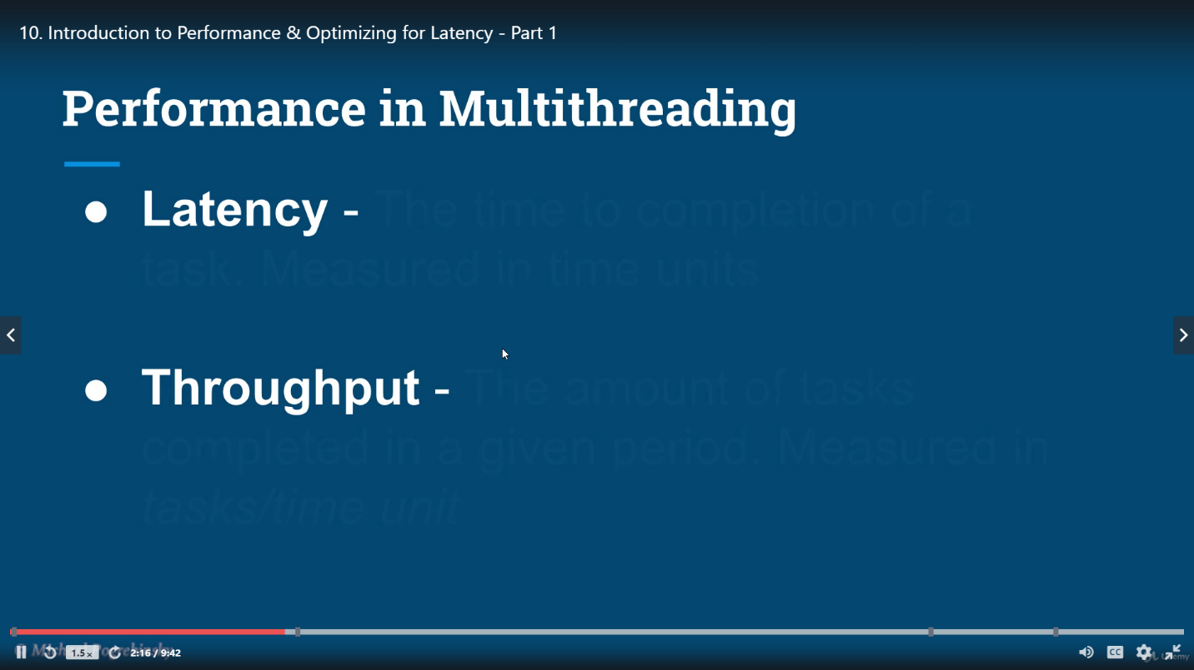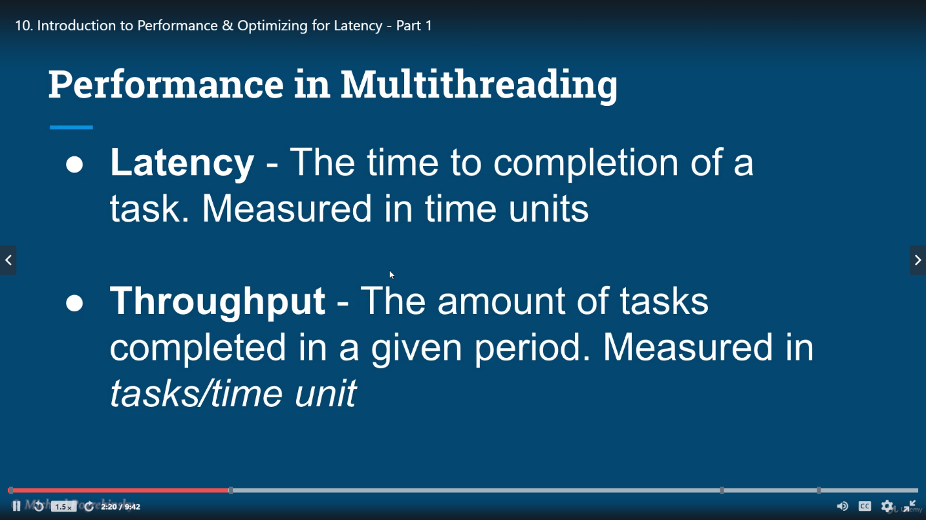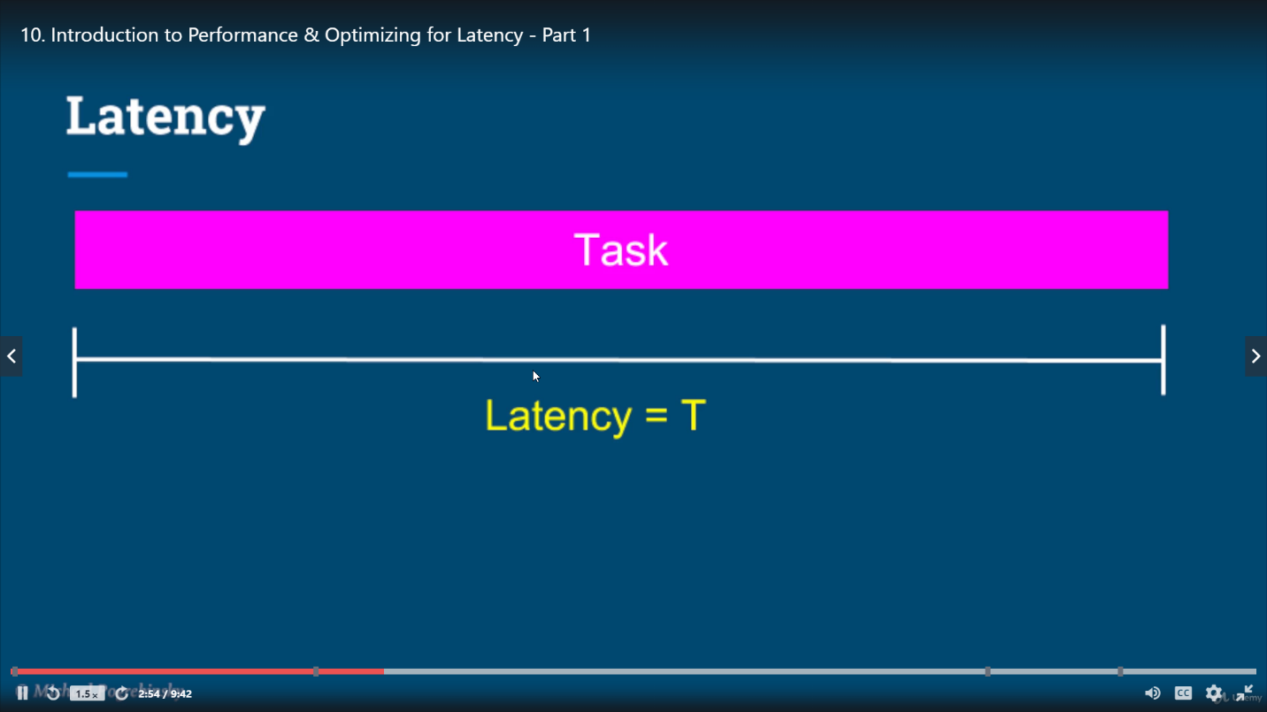

## Break the task in small tasks and run them parallelly to reduce latency

## Latency and throughput

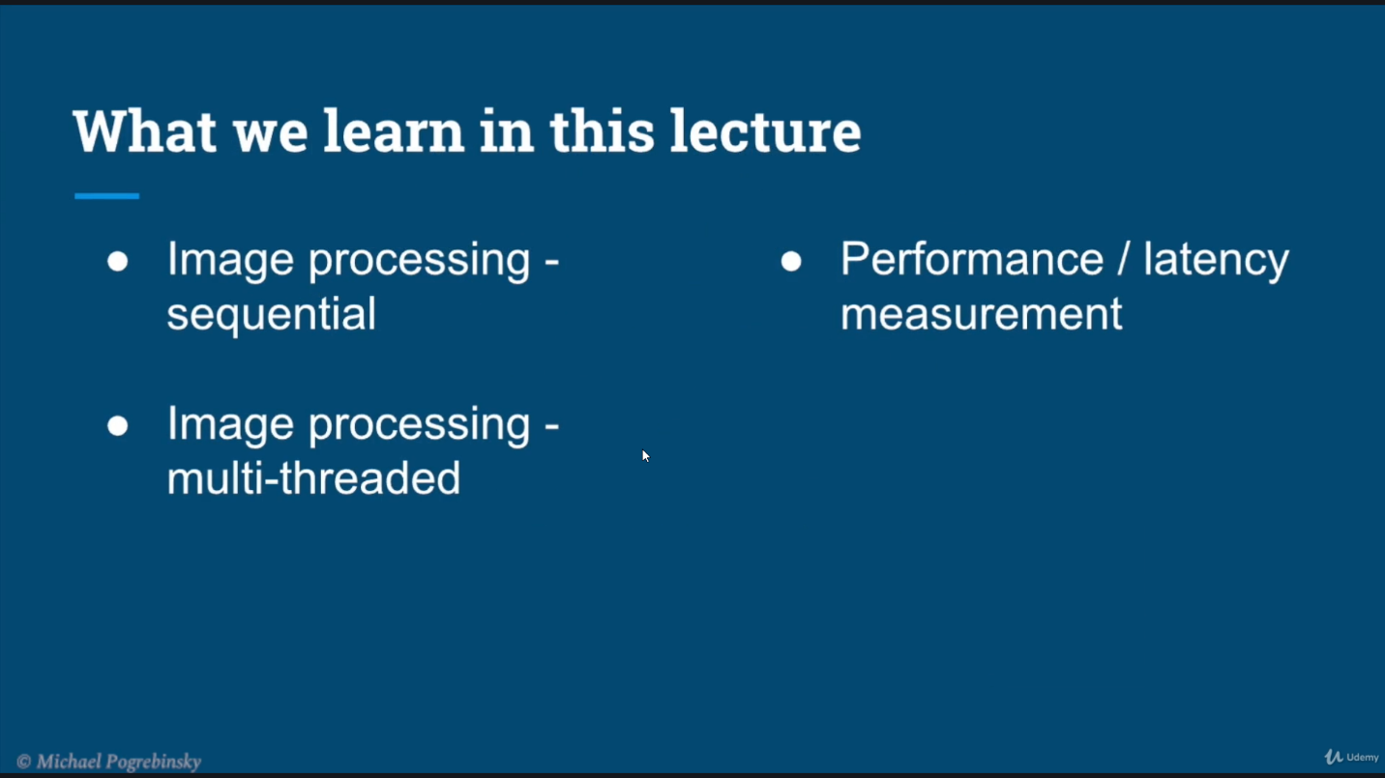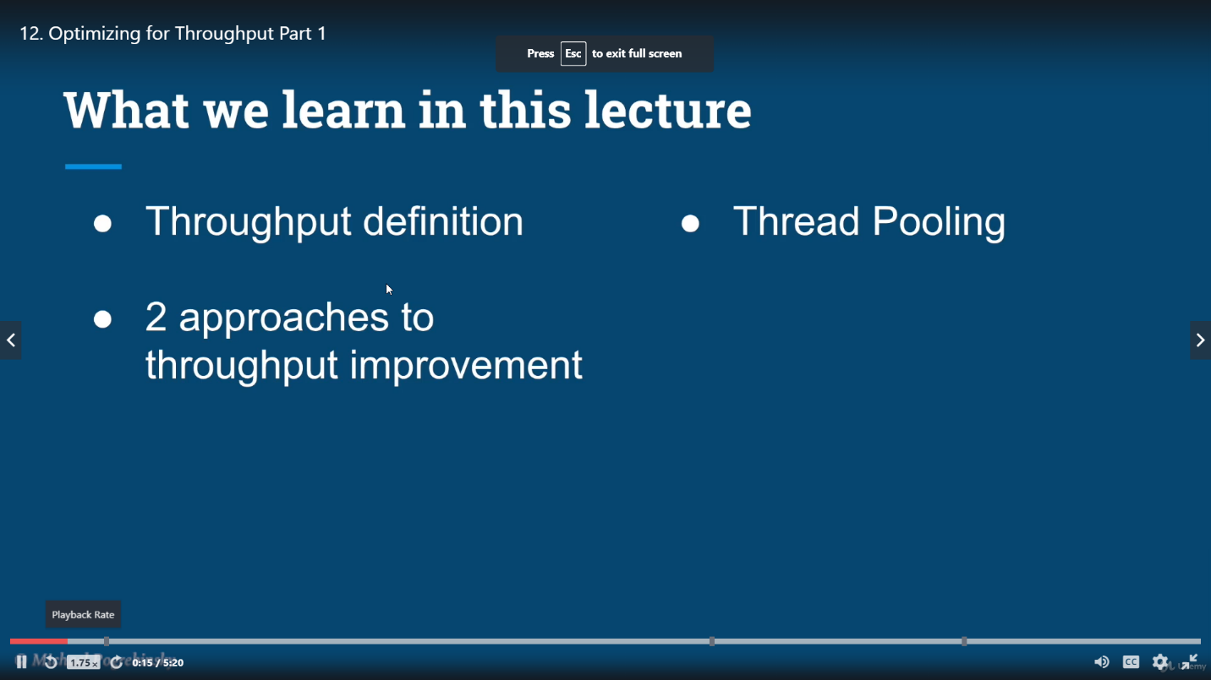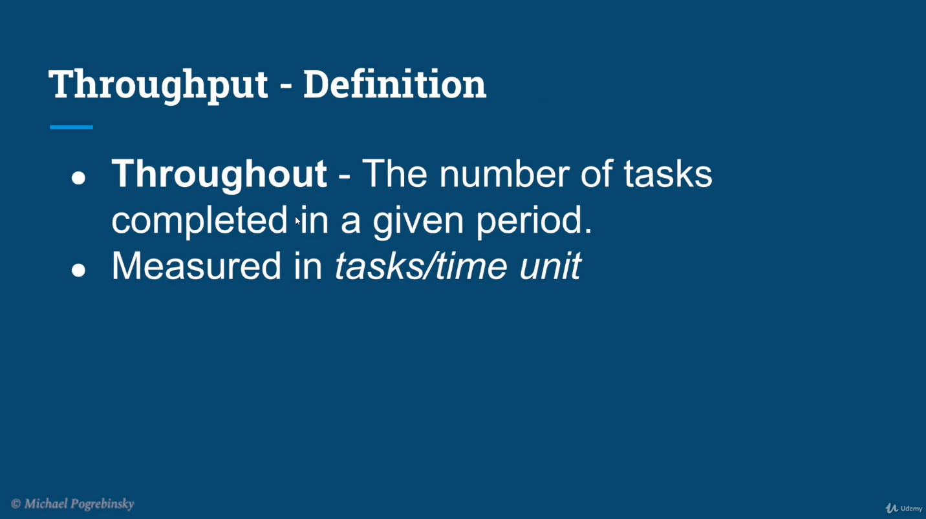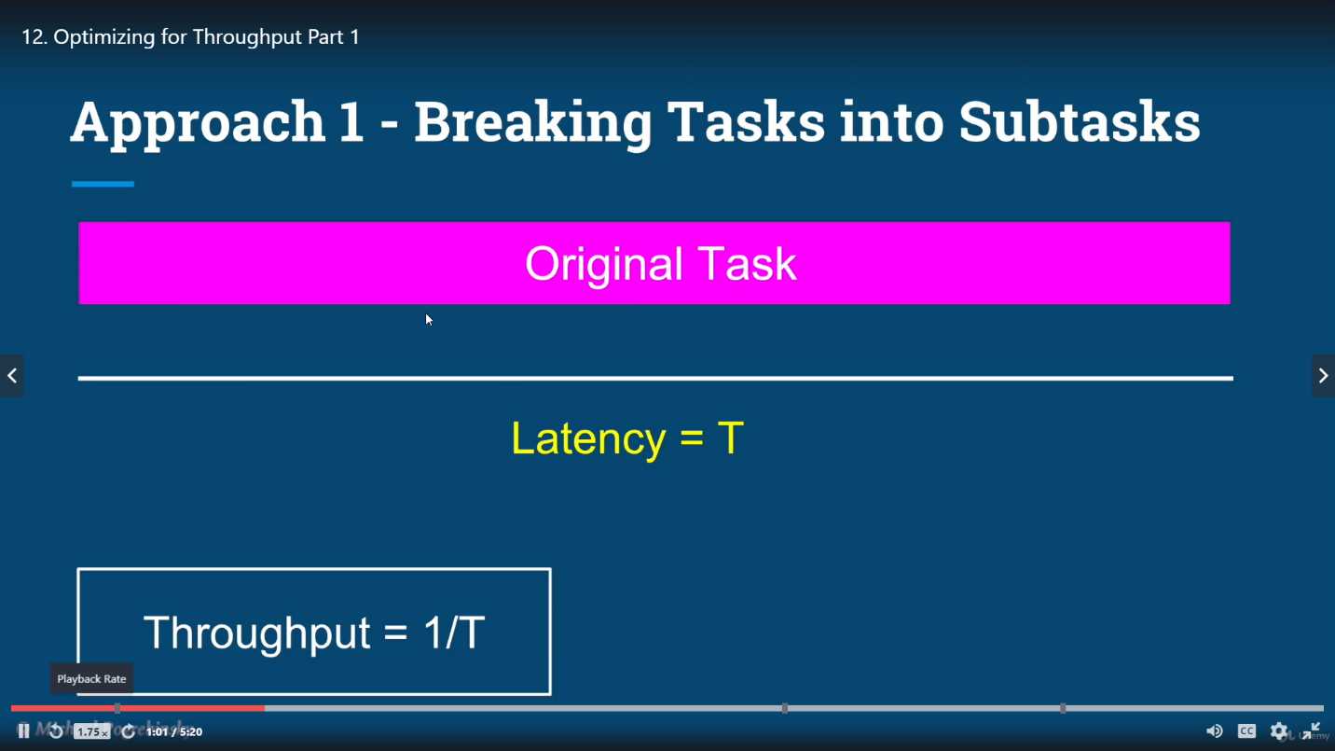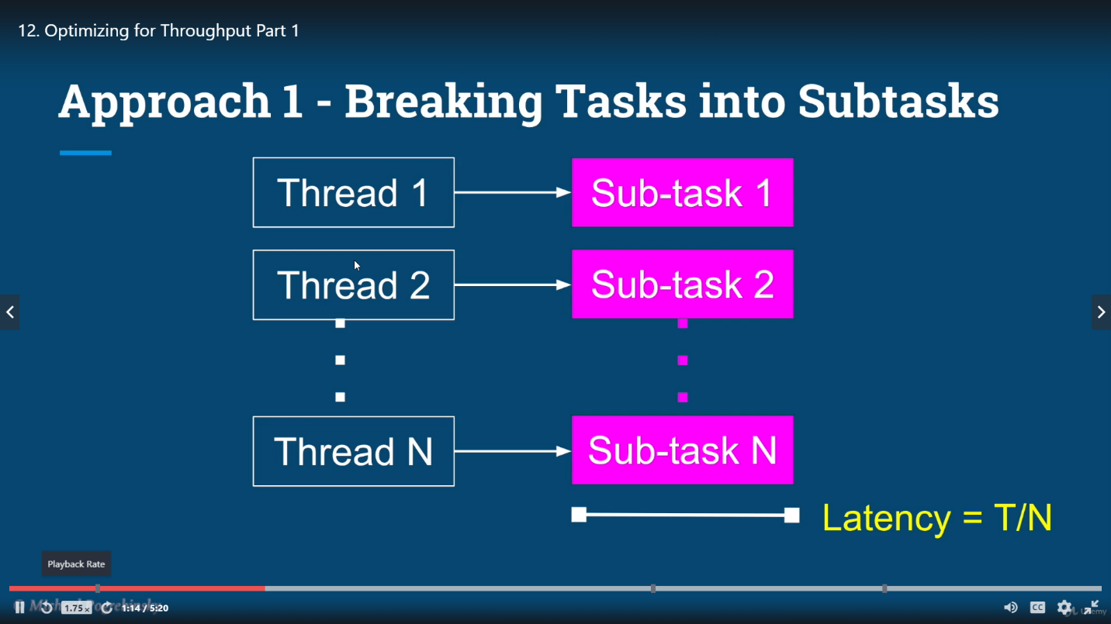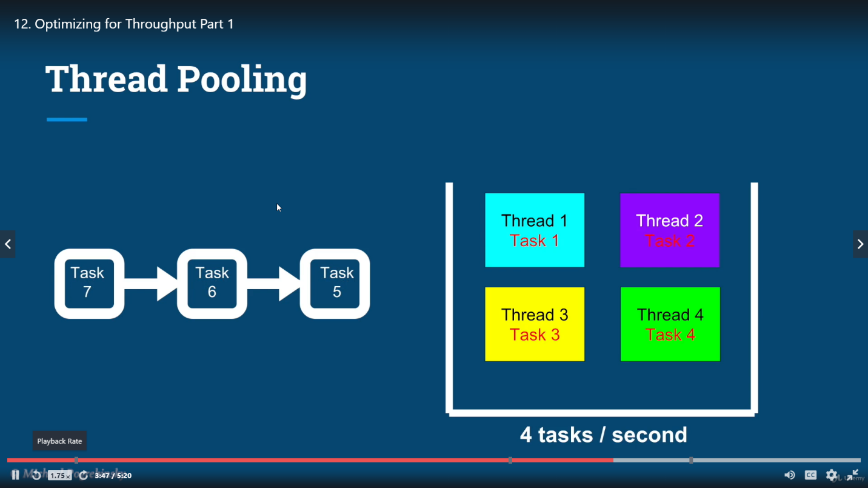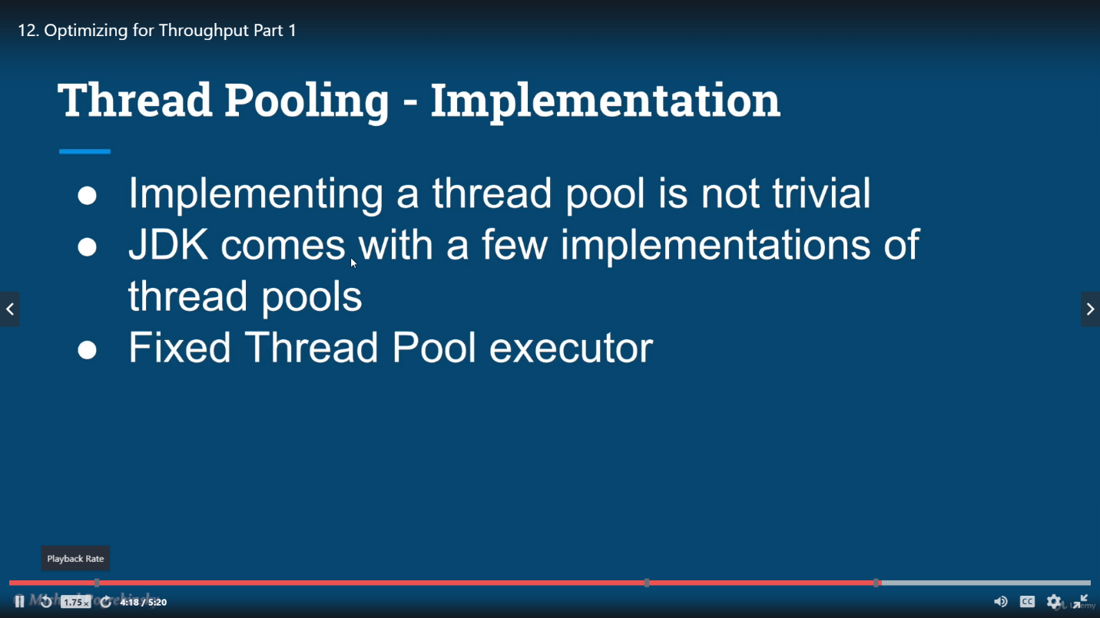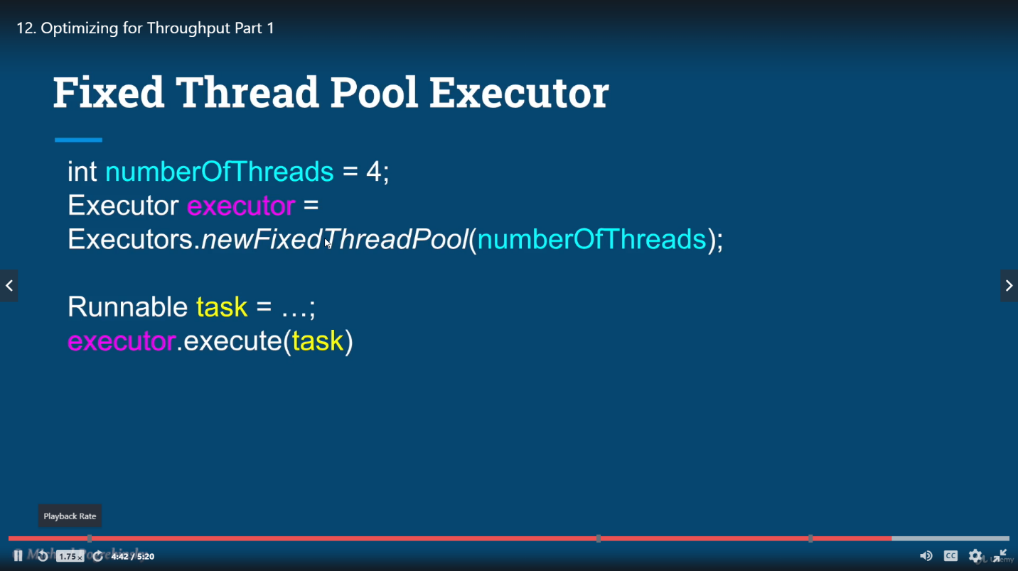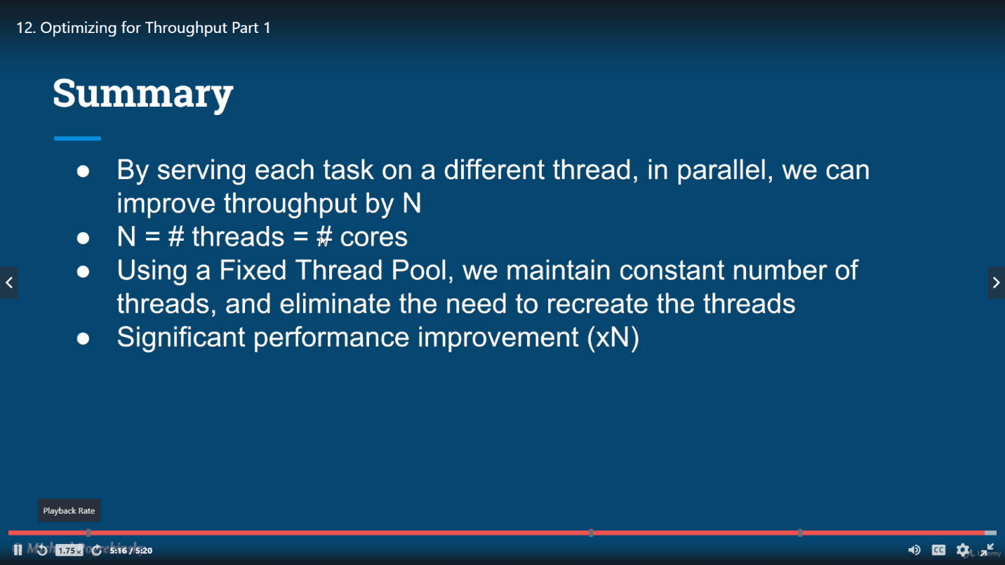

# Memory sharing

## Stack and heap

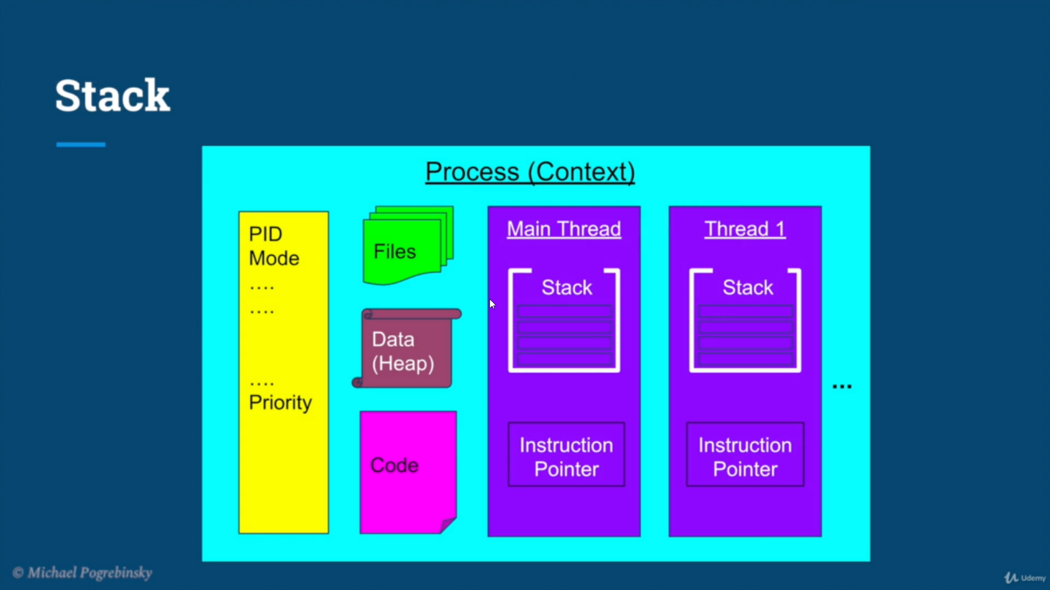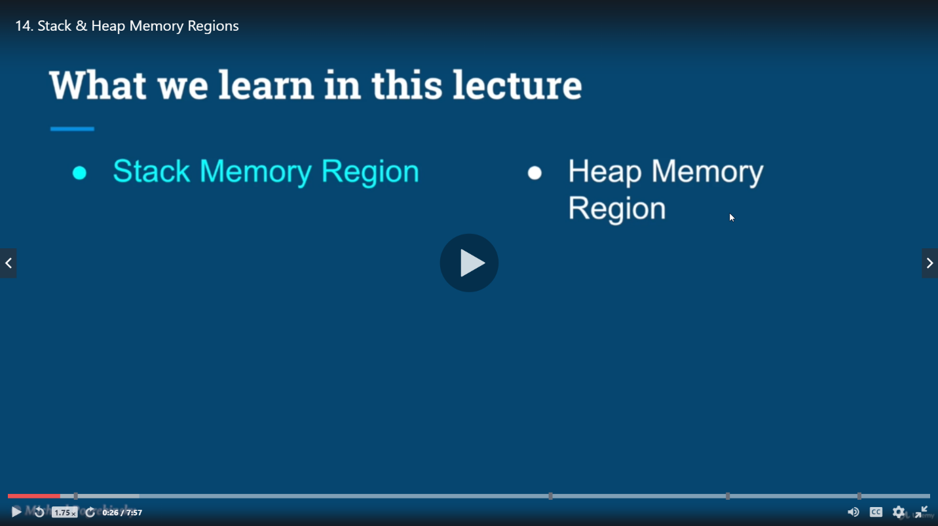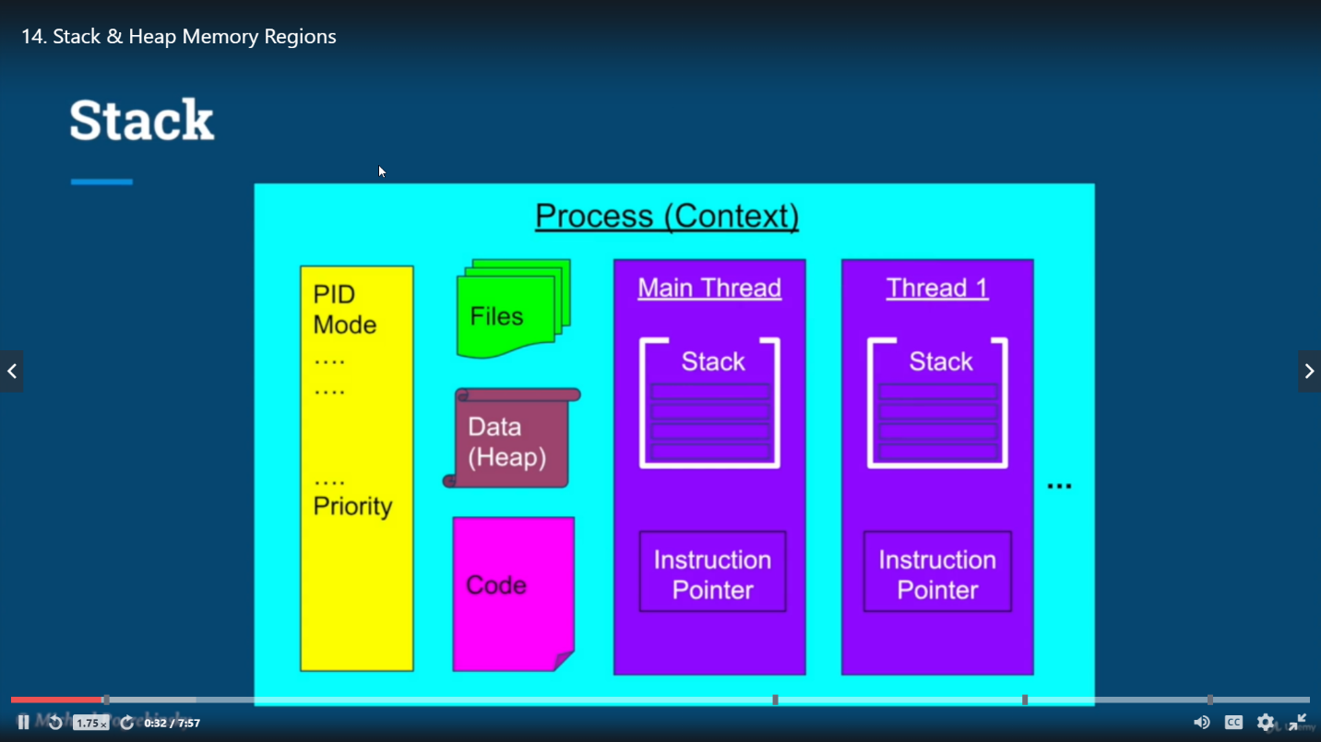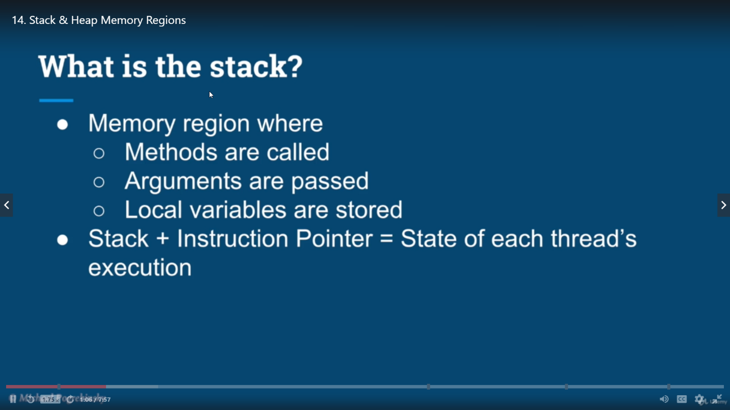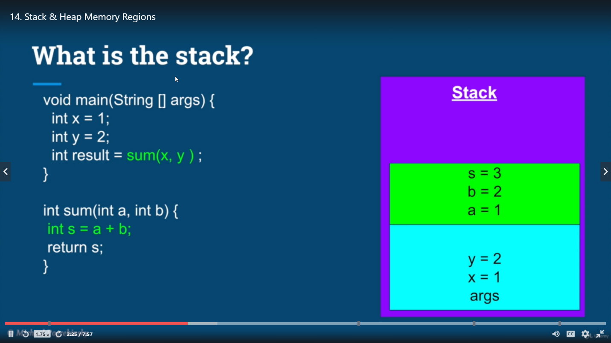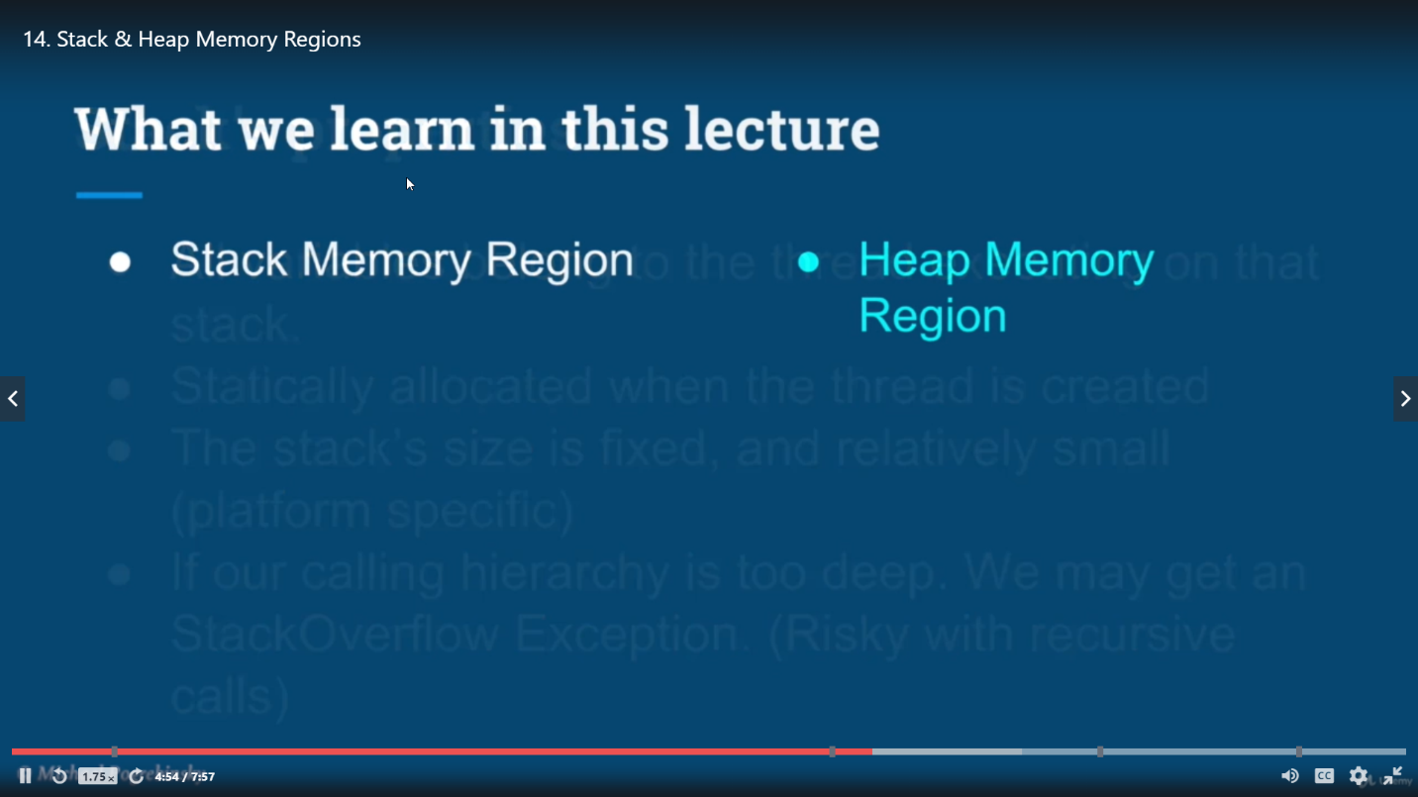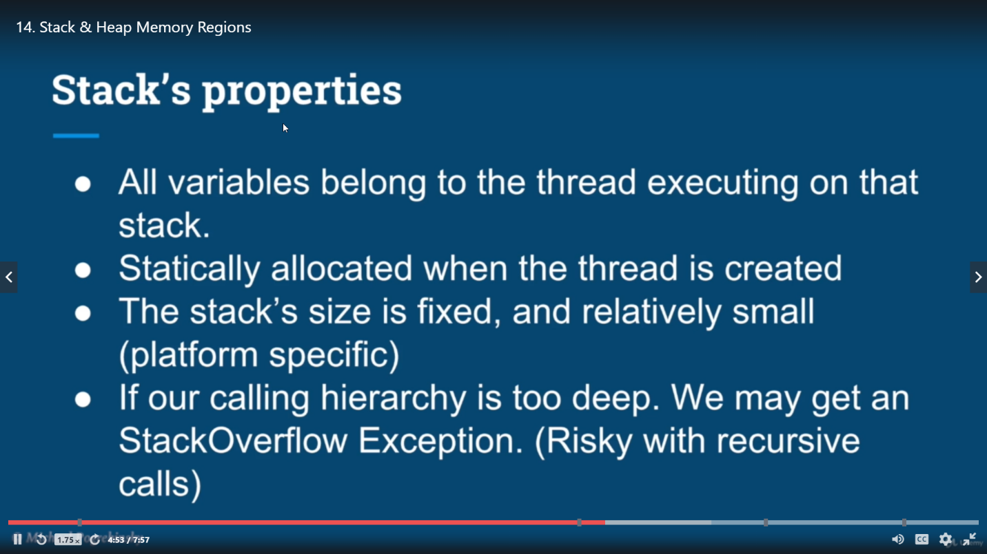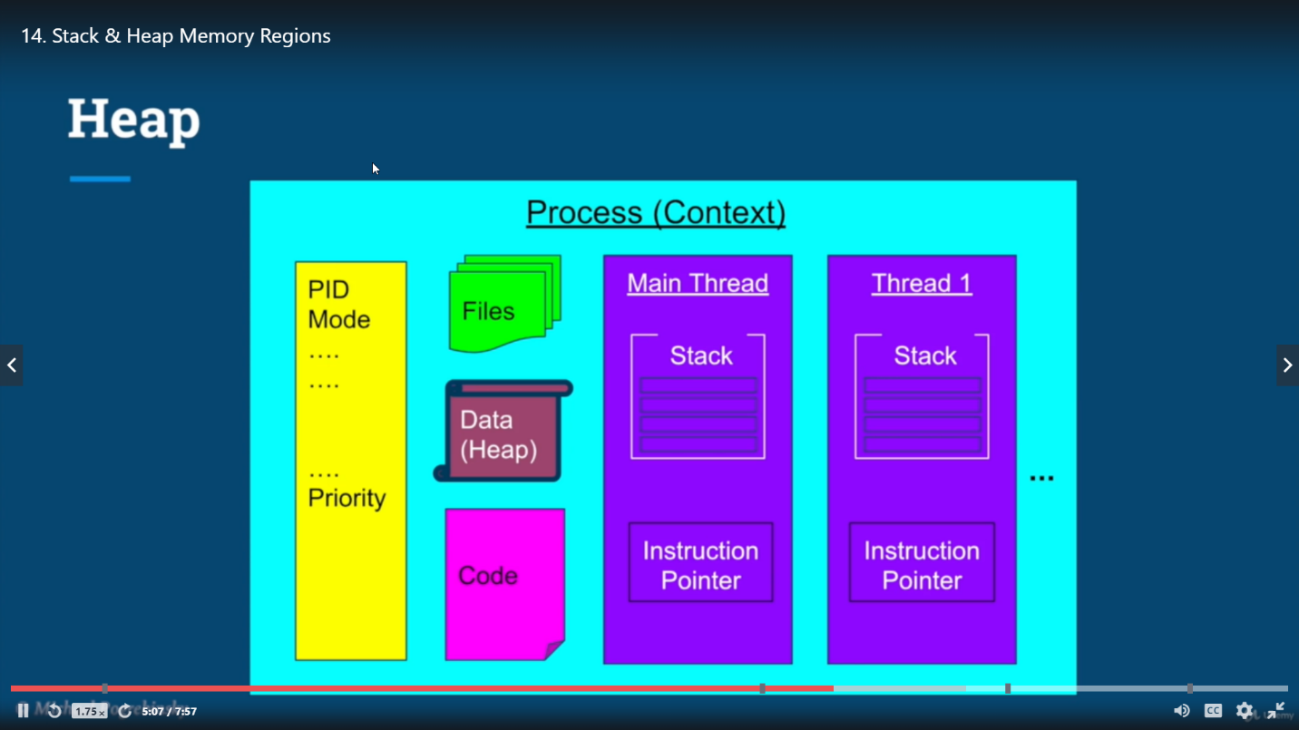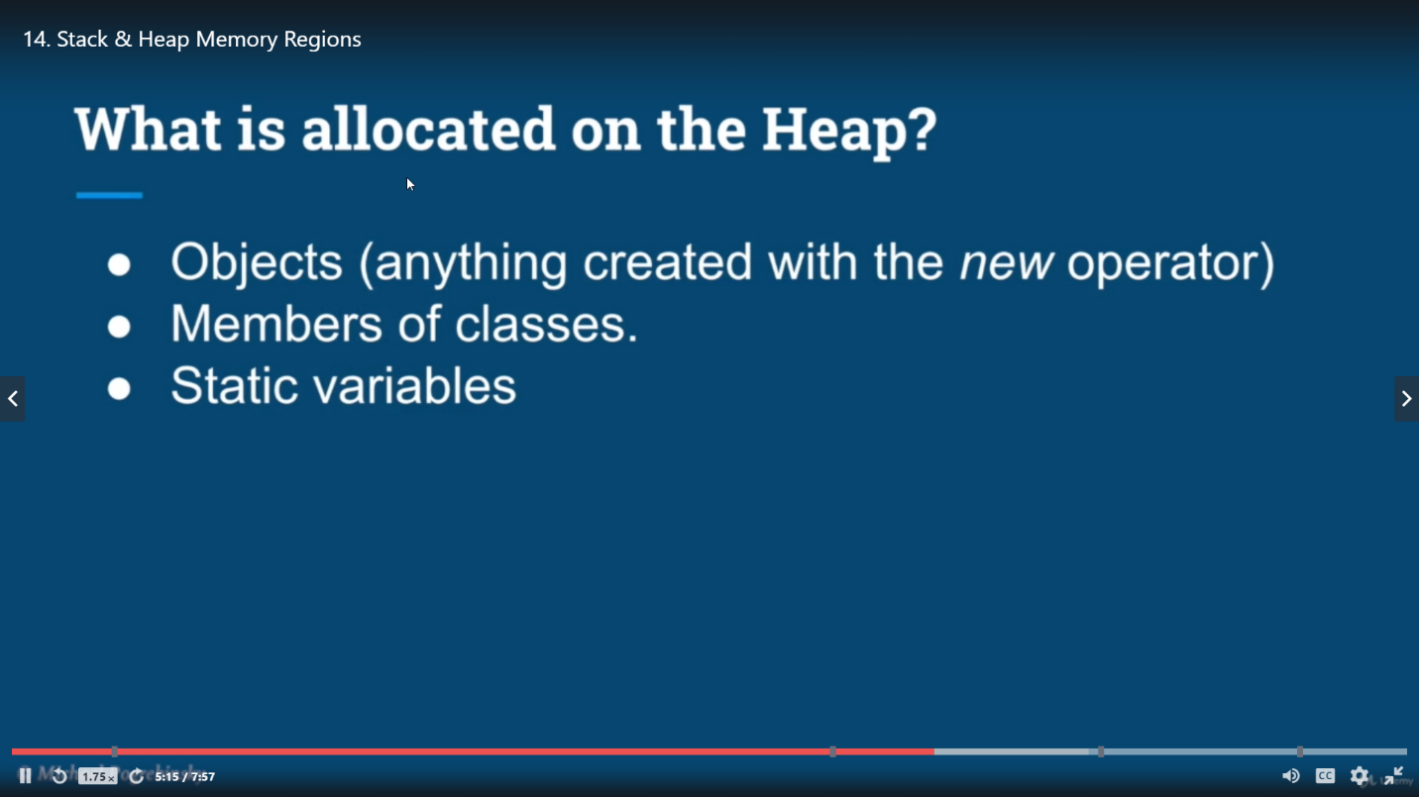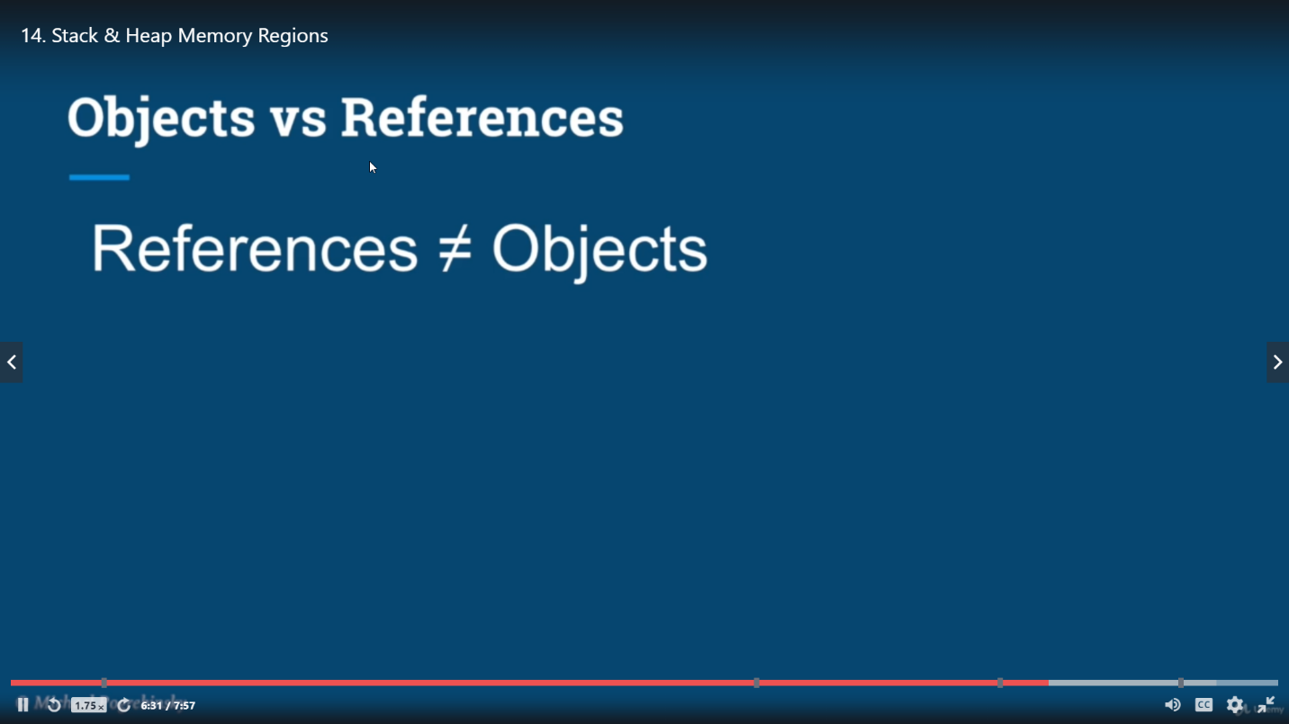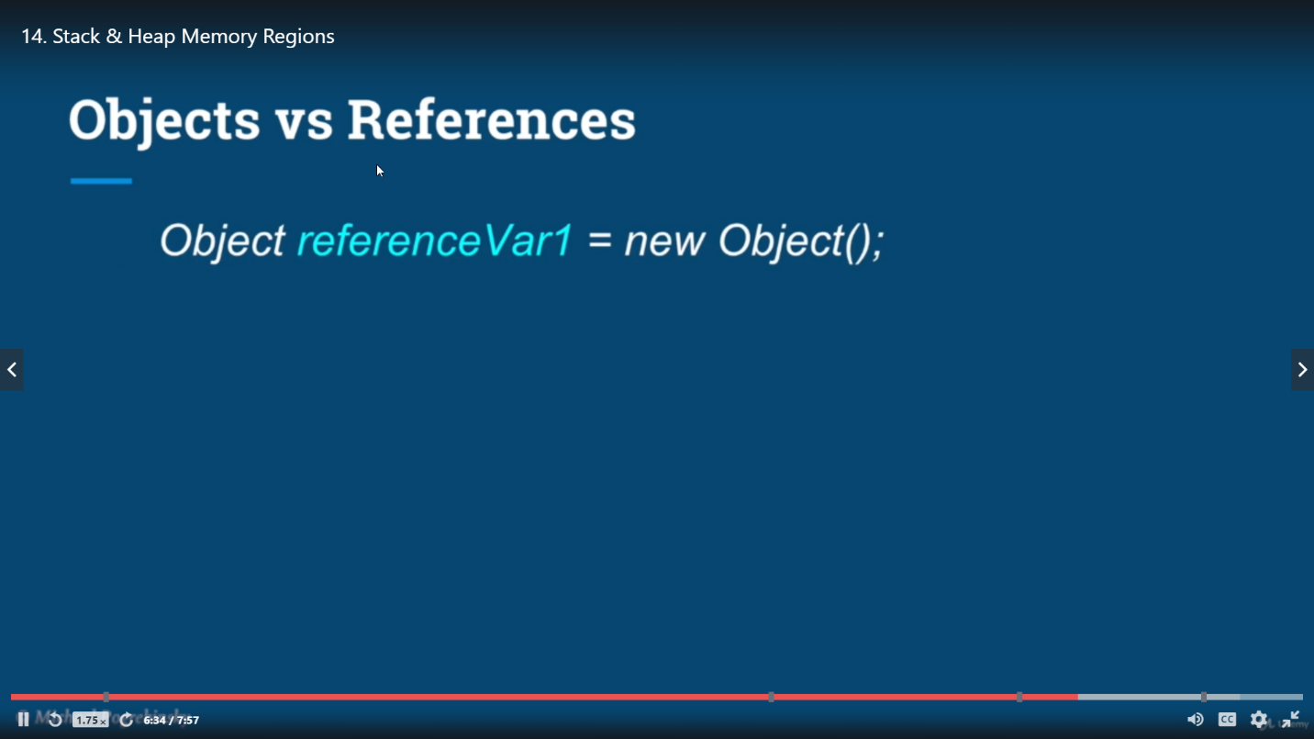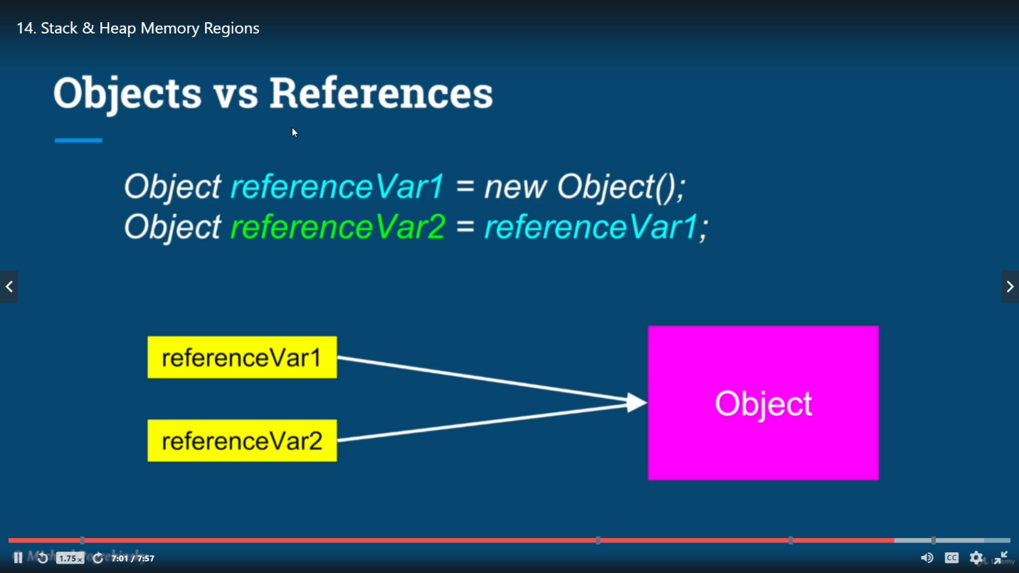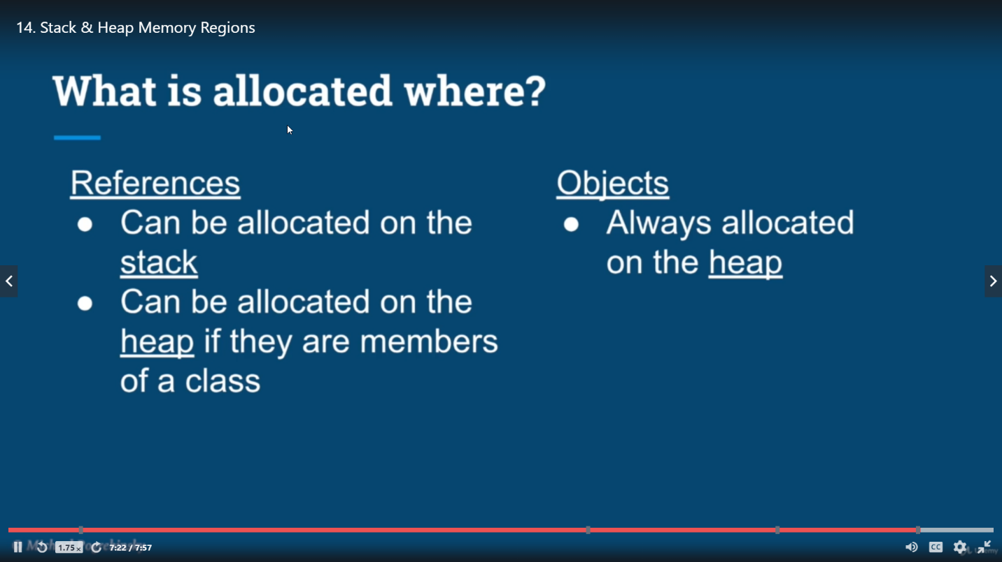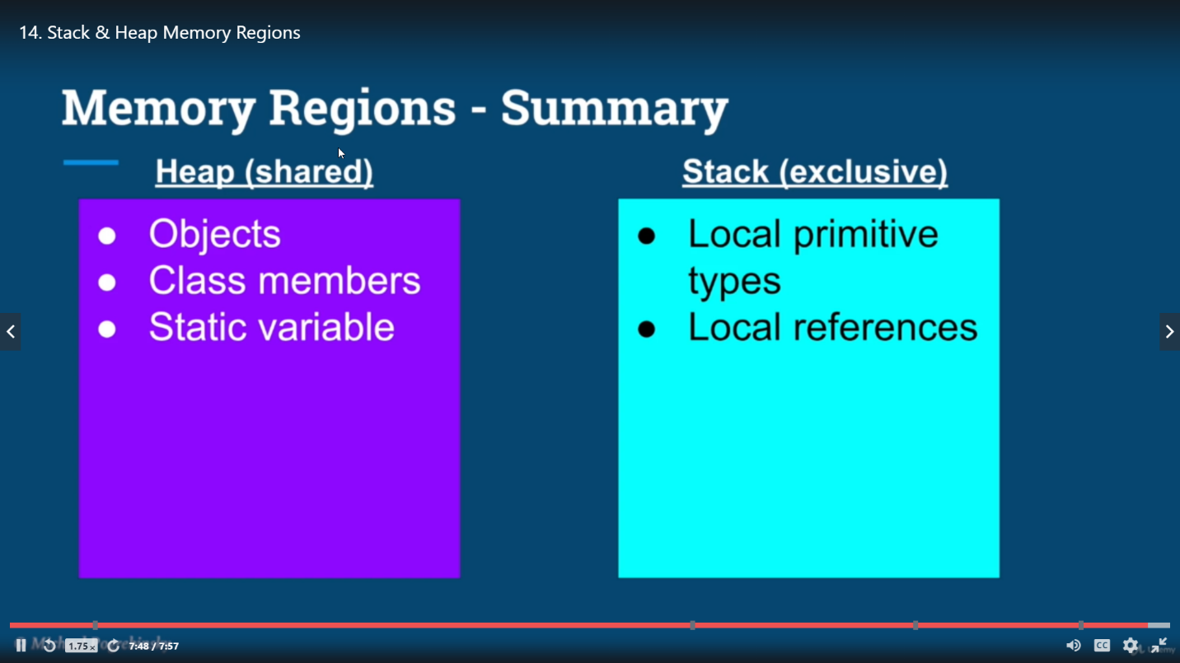

## Challenges in Multithreading

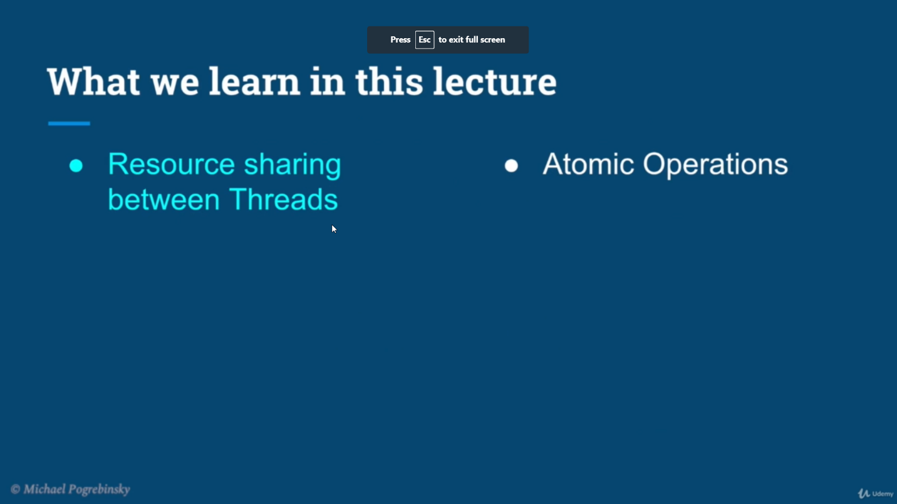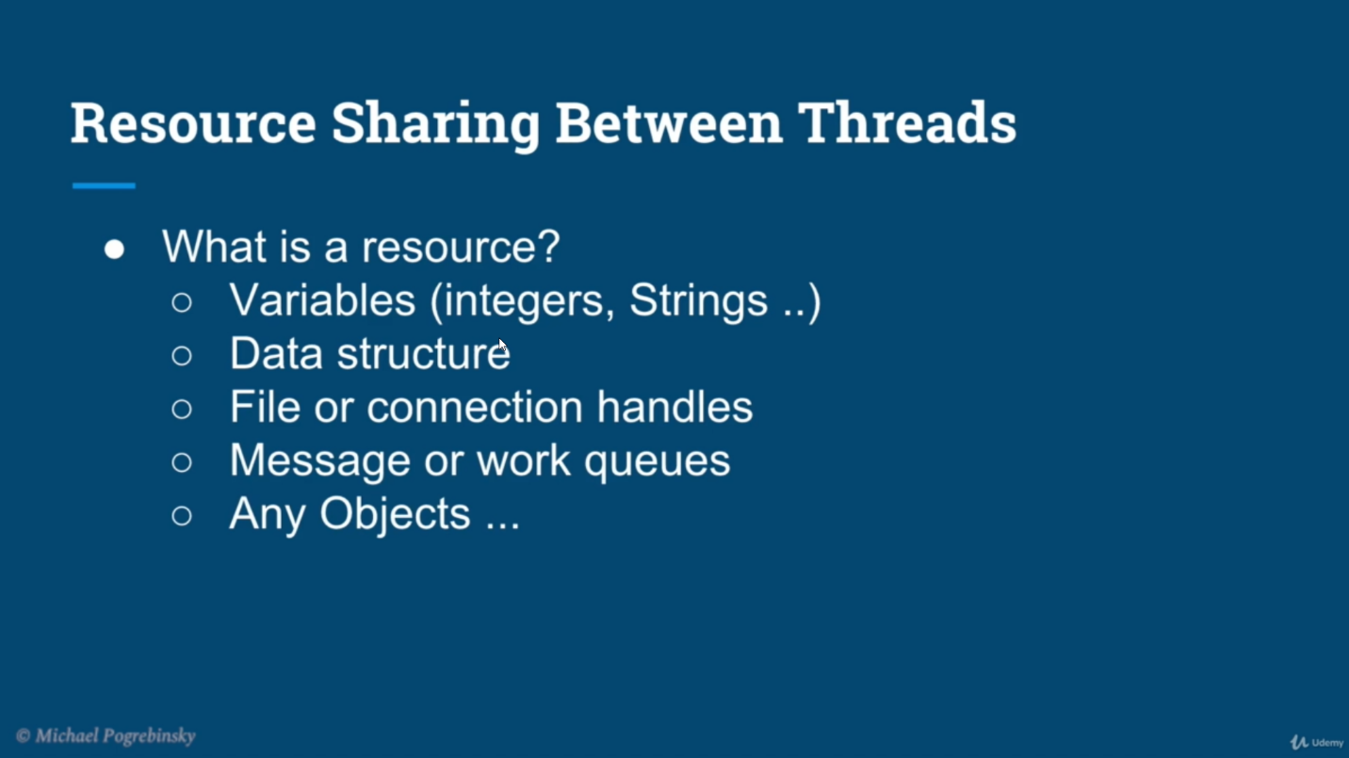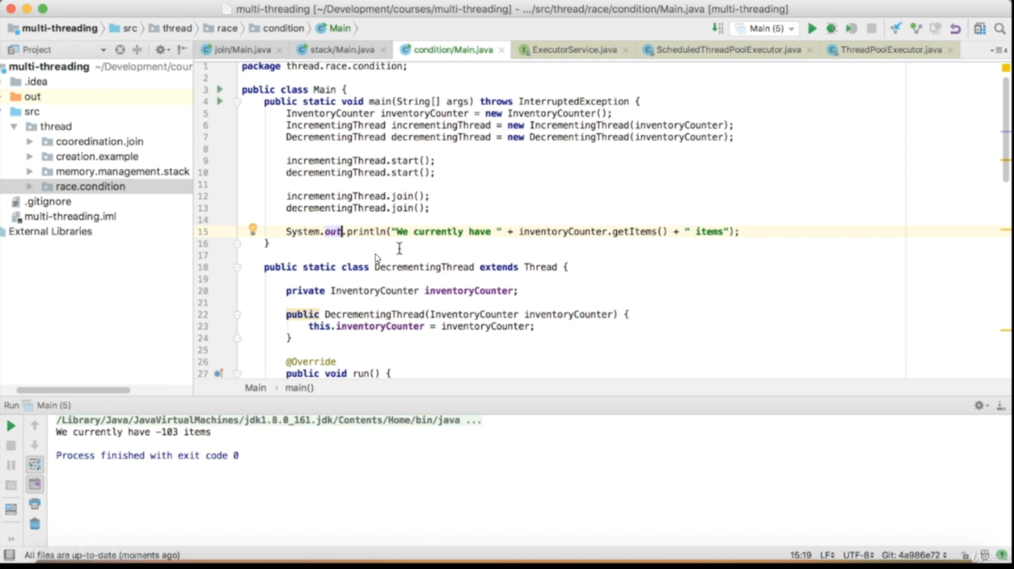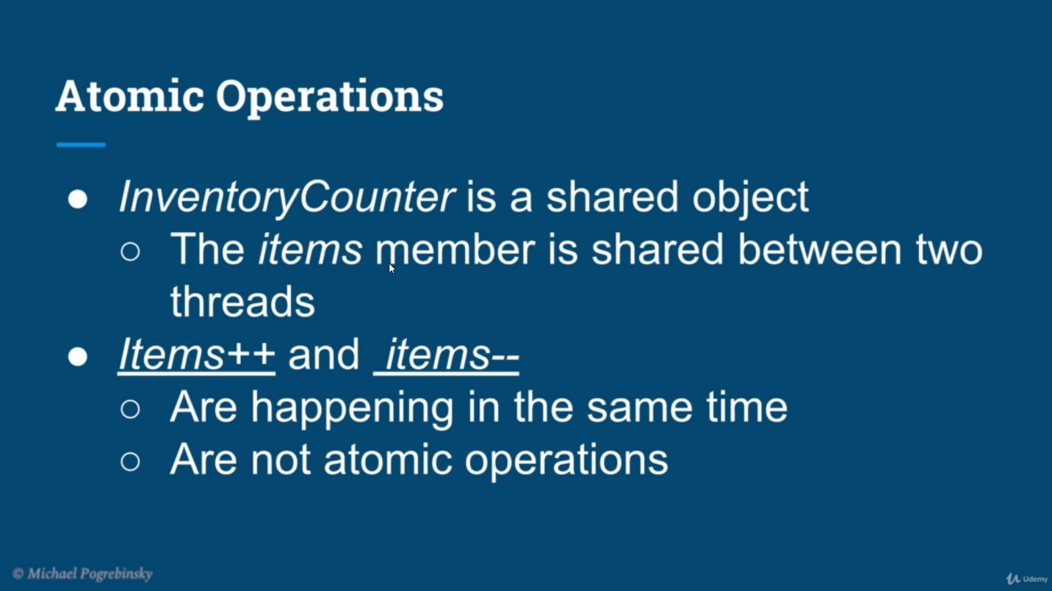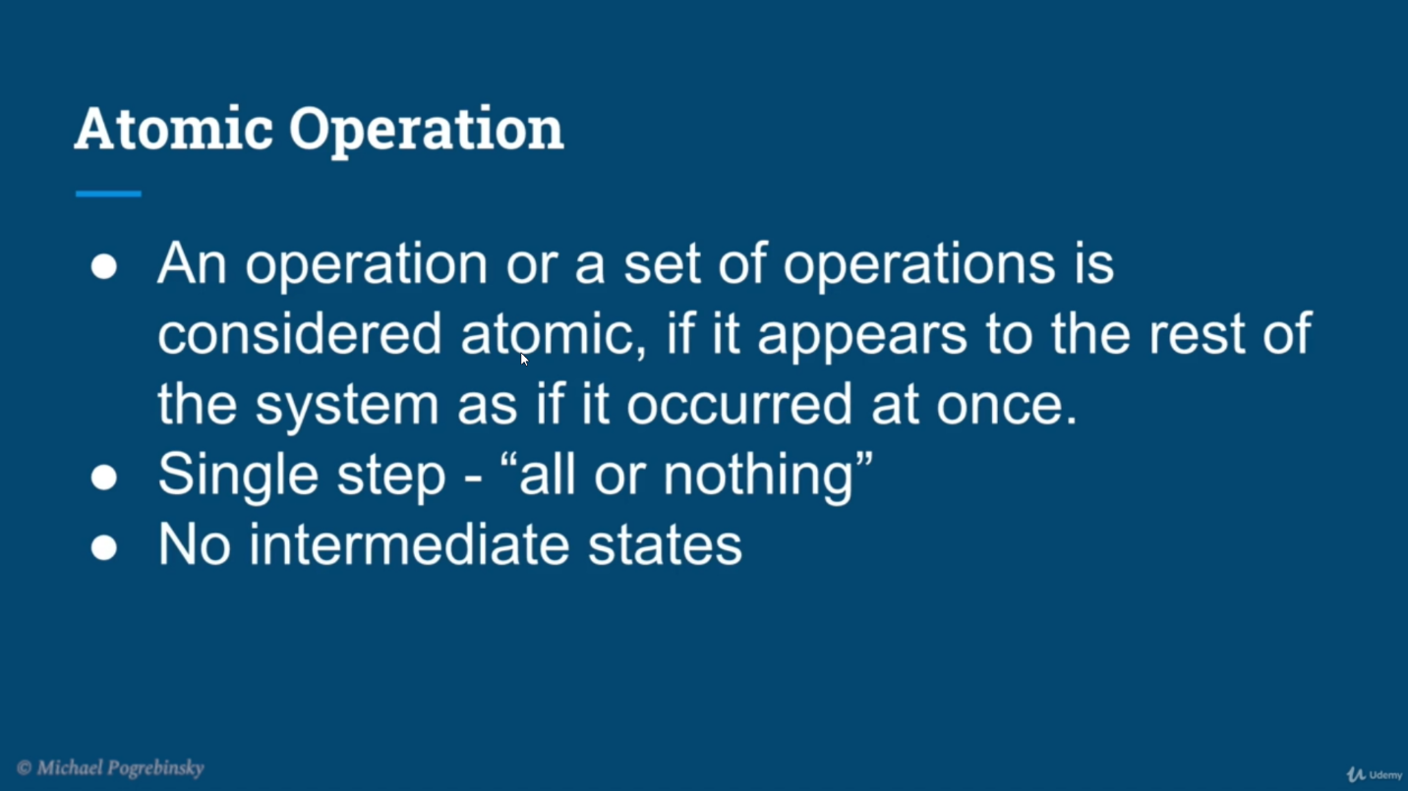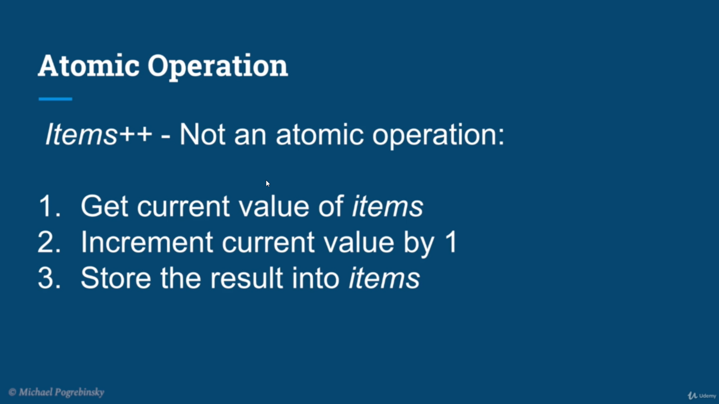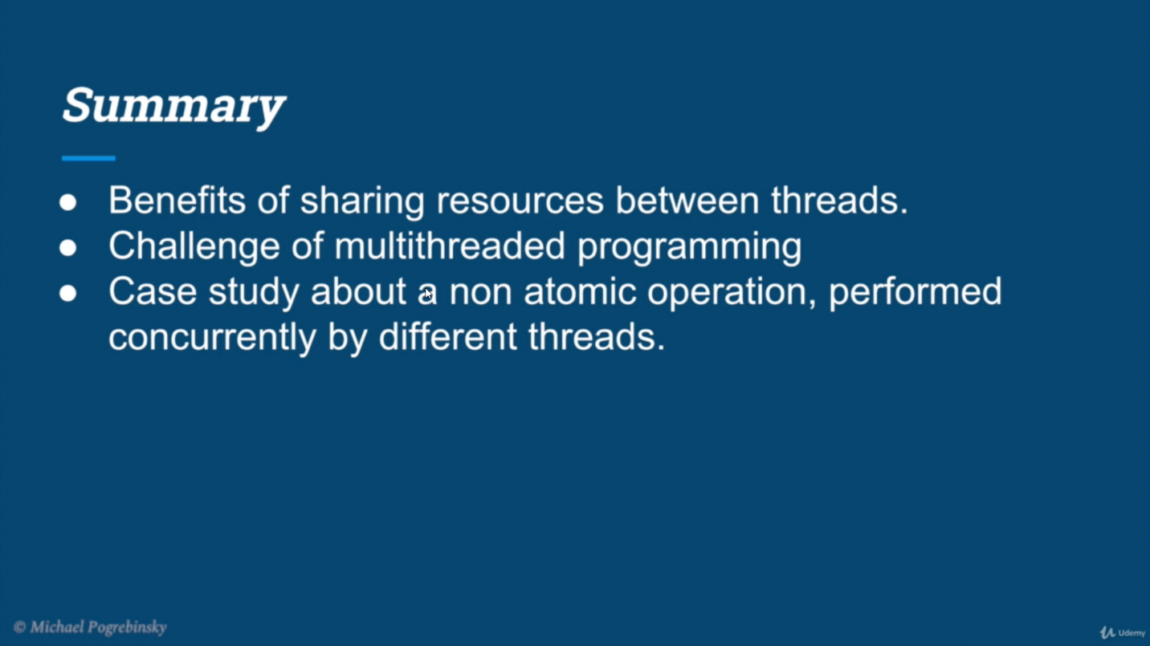

# Synchronized

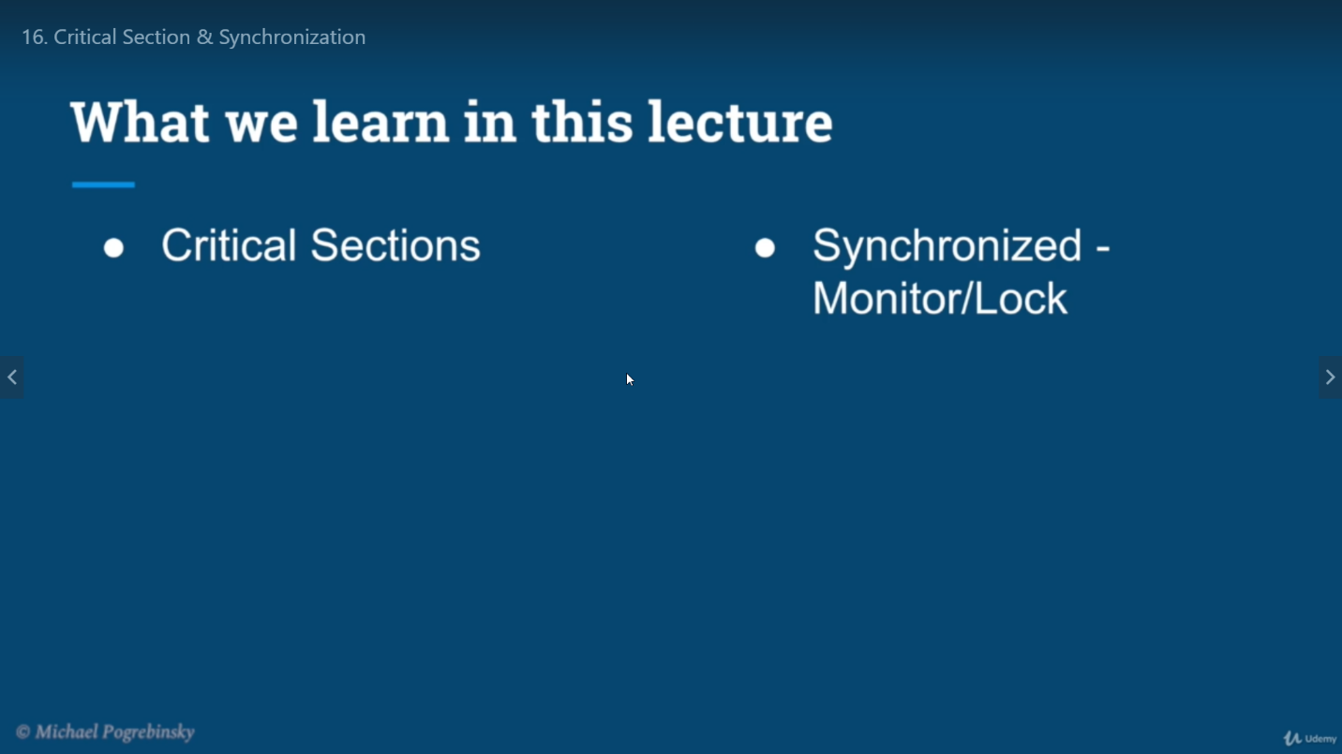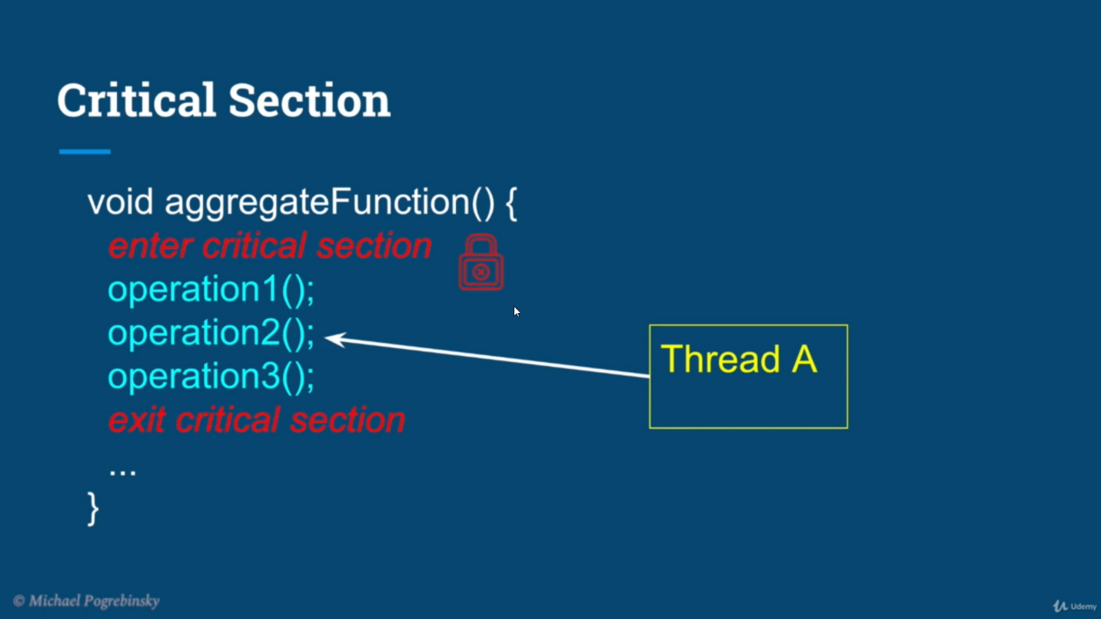

## If thread A is in critical section and synchronized is in monitor status(locked at function level) Thread B will not be able to enter critical section.

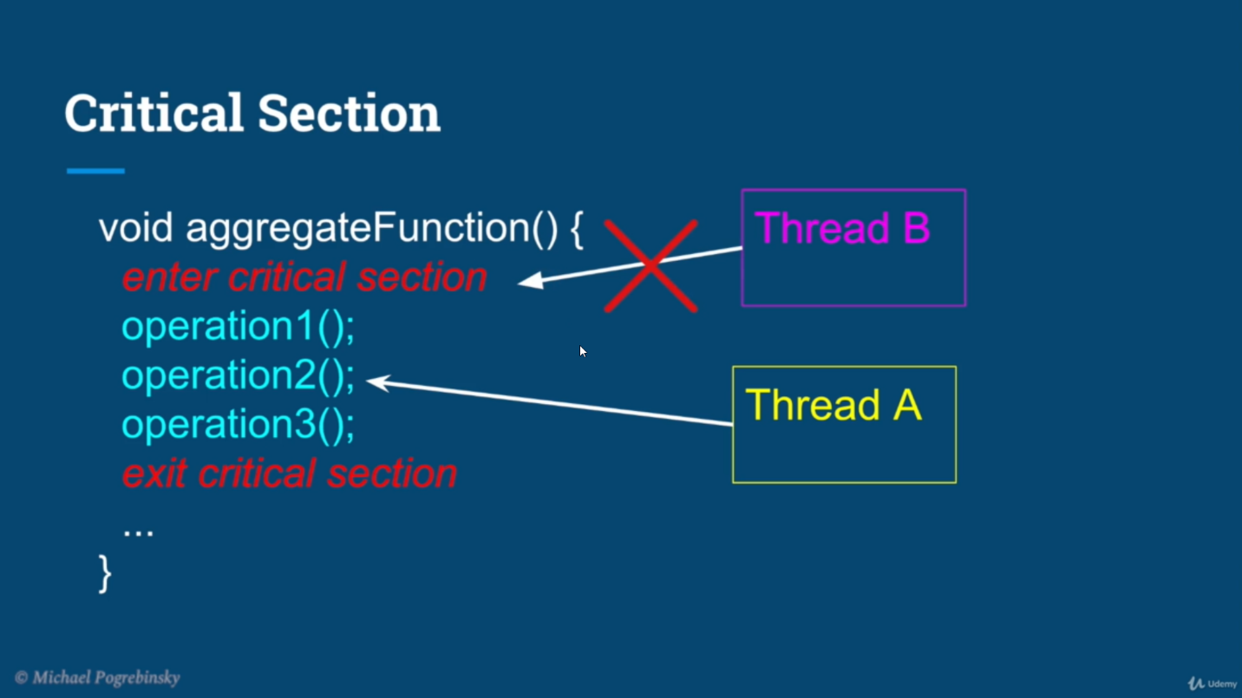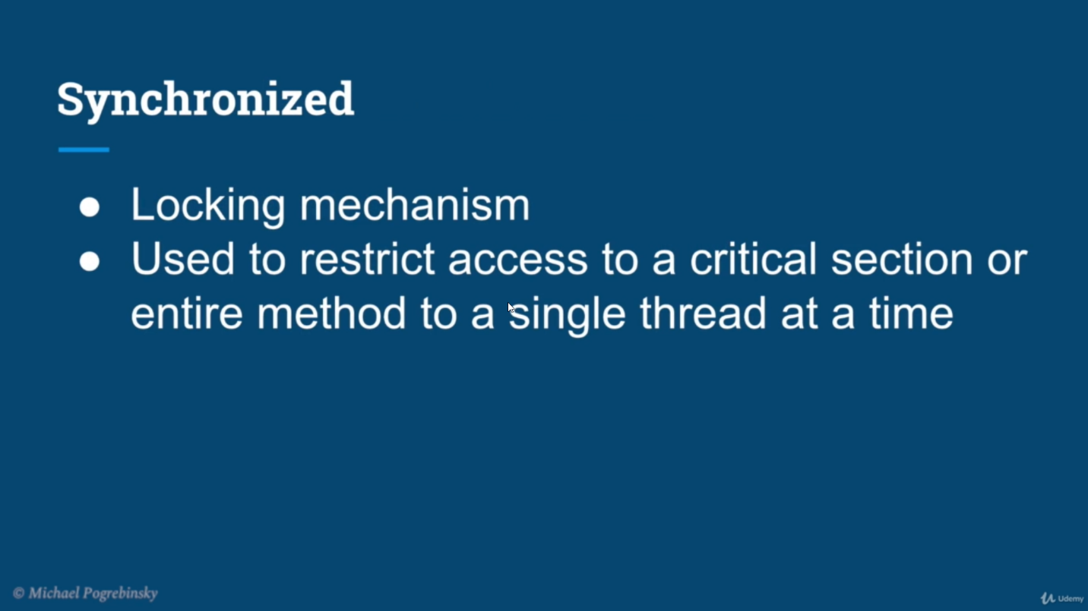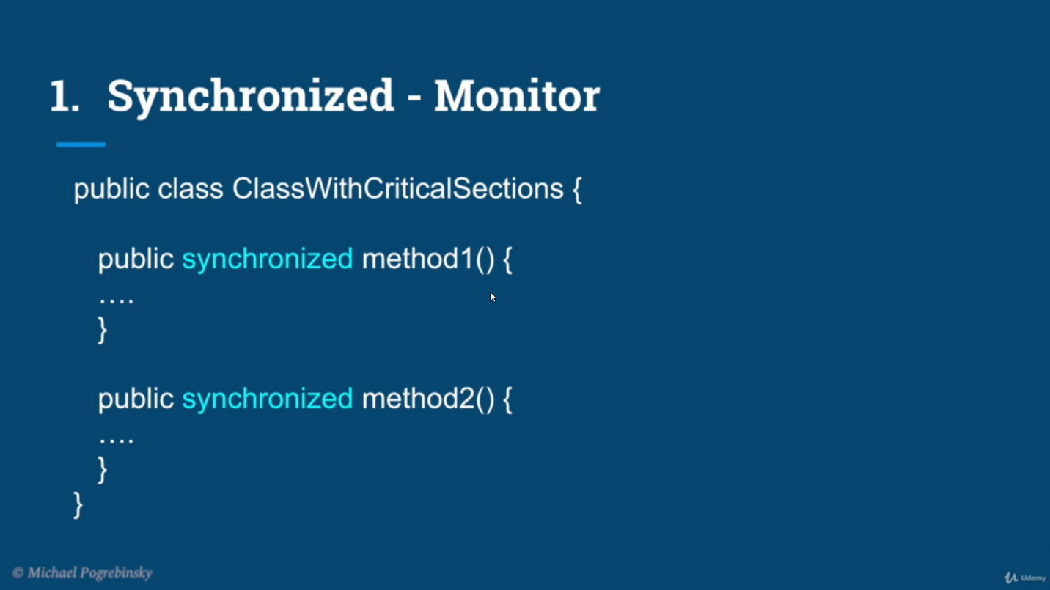

## In case of monitor synchronized, thread B cannot access any of synchronized method within That object

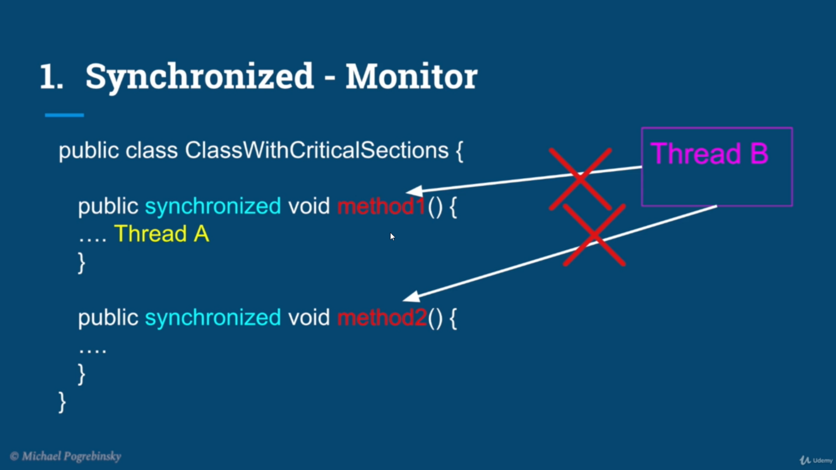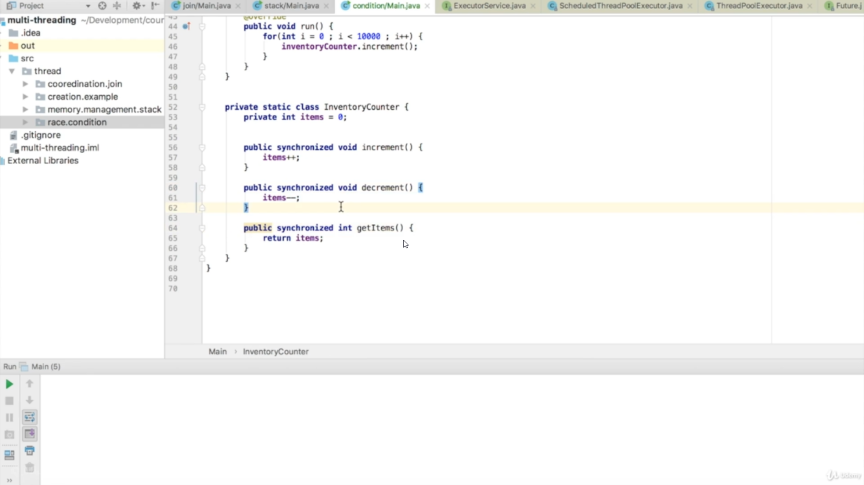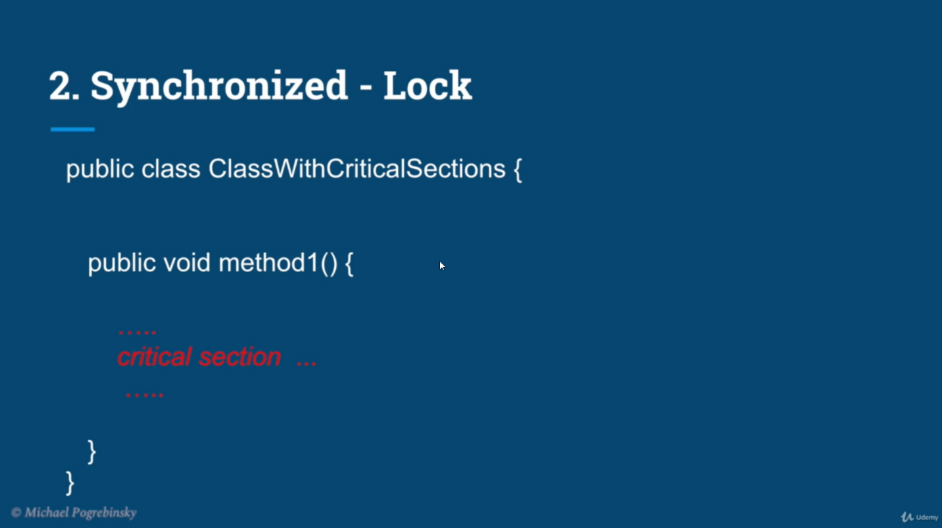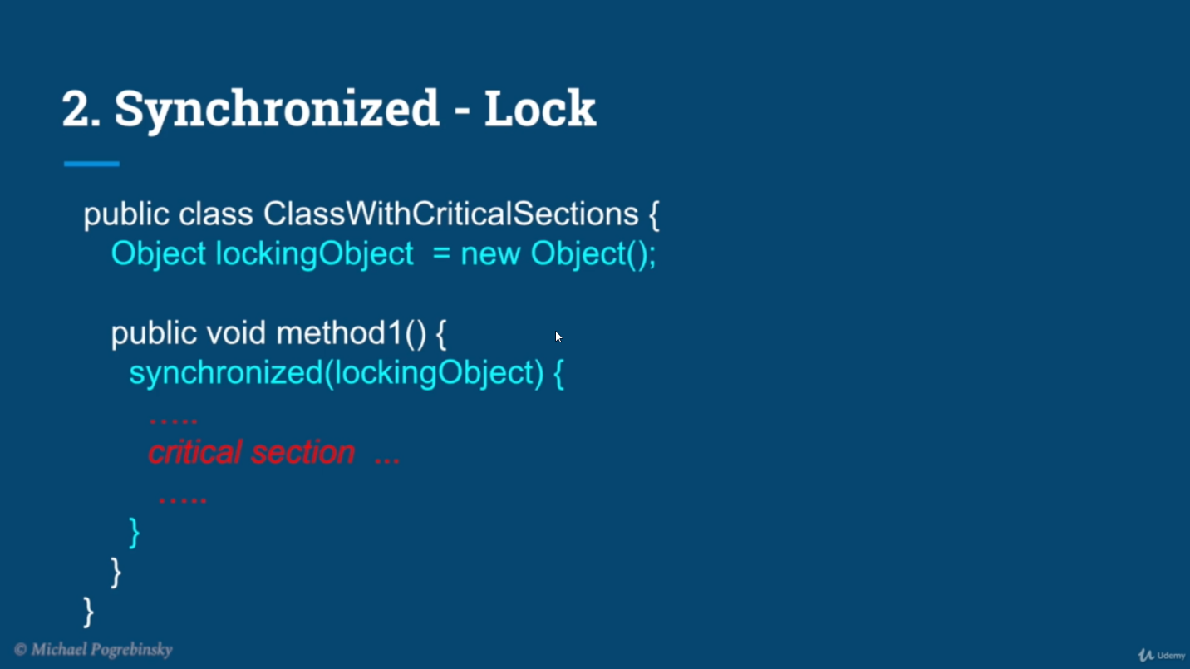

## In synchronized-lock Thread B can access different methods of locked object, but not the same function

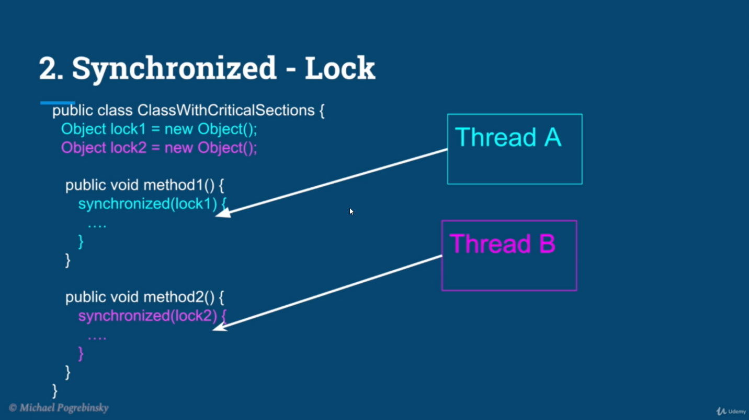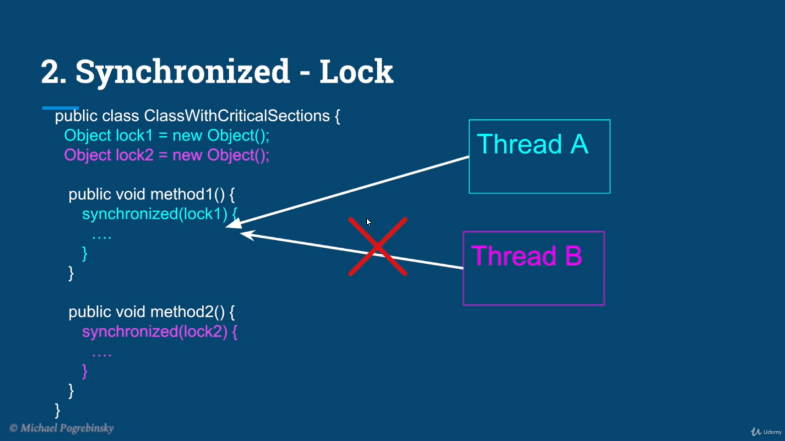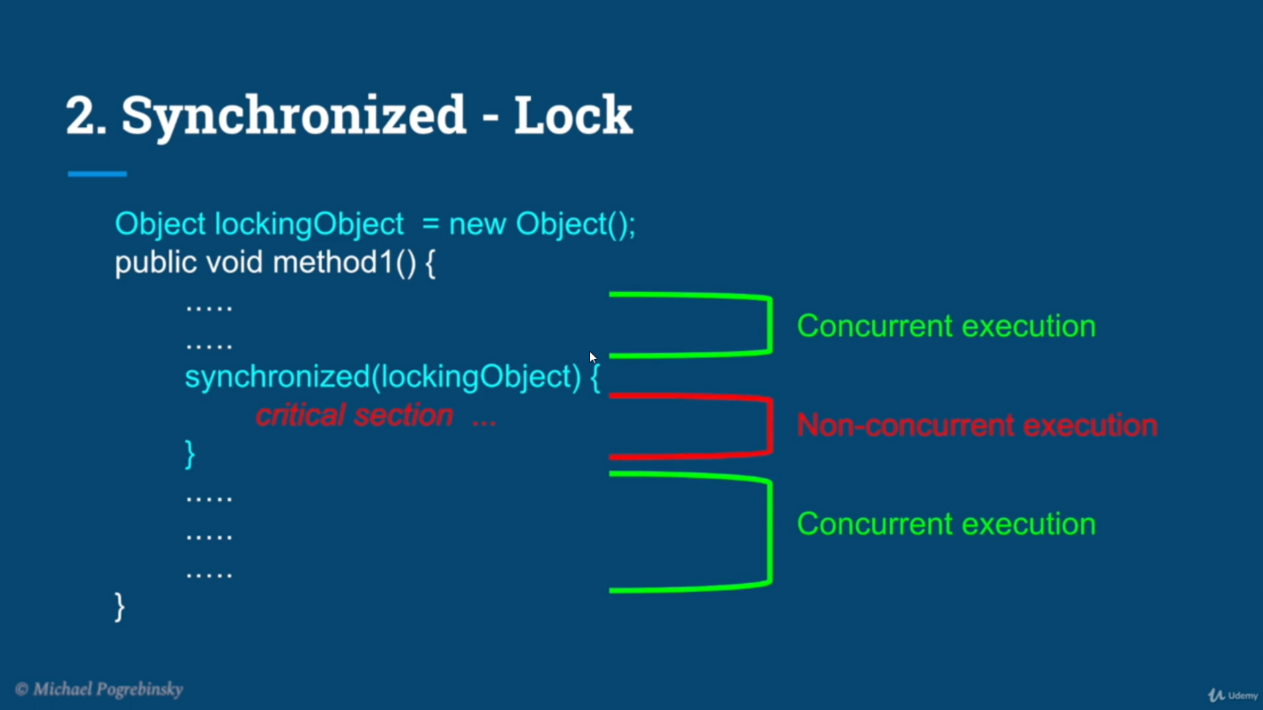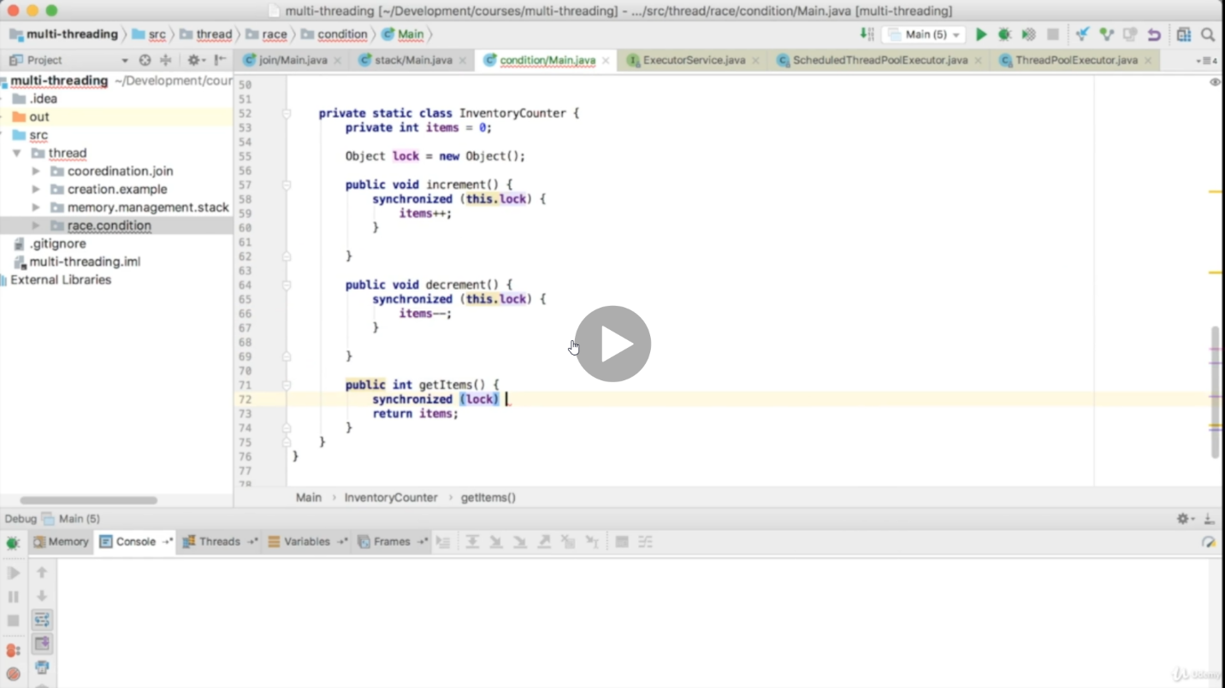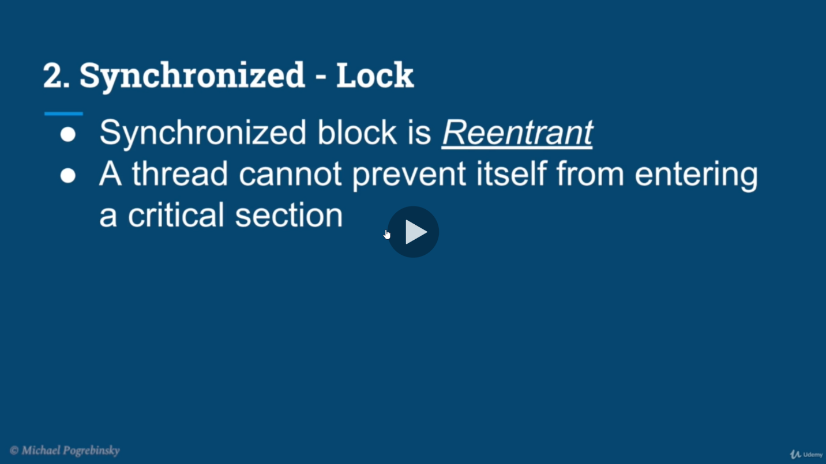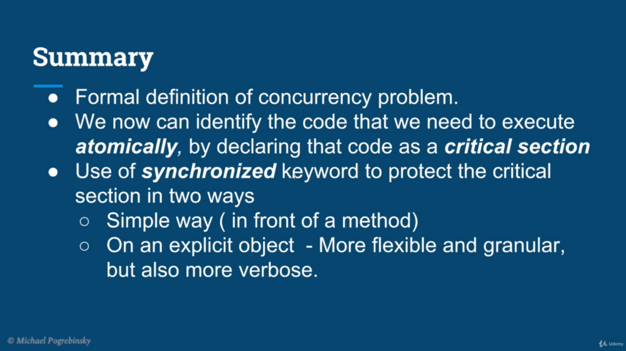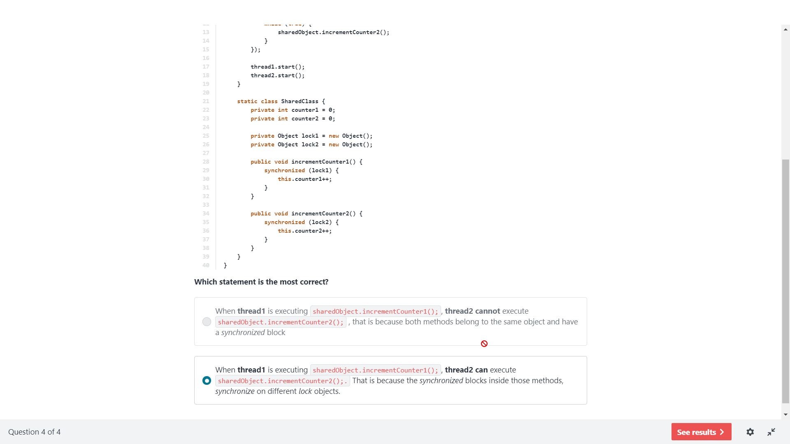

### Consumer Producer

[Producer-Consumer solution using threads in Java - GeeksforGeeks](https://www.geeksforgeeks.org/producer-consumer-solution-using-threads-java/)

### Program for synchronization

// A Java program to demonstrate working of

// synchronized.

import java.io.*;

import java.util.*;

// A Class used to send a message

class Sender

{

public void send(String msg)

{

System.out.println("Sending\t" + msg );

try

{

Thread.sleep(1000);

}

catch (Exception e)

{

System.out.println("Thread interrupted.");

}

System.out.println("\n" + msg + "Sent");

}

}

// Class for send a message using Threads

class ThreadedSend extends Thread

{

private String msg;

Sender sender;

// Receives a message object and a string

// message to be sent

ThreadedSend(String m, Sender obj)

{

msg = m;

sender = obj;

}

public void run()

{

// Only one thread can send a message

// at a time.

synchronized(sender)

{

// synchronizing the snd object

sender.send(msg);

}

}

}

// Driver class

class SyncDemo

{

public static void main(String args[])

{

Sender snd = new Sender();

ThreadedSend S1 =

new ThreadedSend( " Hi " , snd );

ThreadedSend S2 =

new ThreadedSend( " Bye " , snd );

// Start two threads of ThreadedSend type

S1.start();

S2.start();

// wait for threads to end

try

{

S1.join();

S2.join();

}

catch(Exception e)

{

System.out.println("Interrupted");

}

}

}

Output:

Sending Hi

Hi Sent

Sending Bye

Bye Sent

## Program wait and notify

class Customer{

int amount=10000;

synchronized void withdraw(int amount){

System.out.println("going to withdraw...");

if(this.amount<amount){

System.out.println("Less balance; waiting for deposit..."); djiuiuojiuu8ijmjmpru8ruriryeufiutur5kritio[tjbguyhbhuygjhbnbbufhgfugfgffffyffhuffgfgffffgghu

try{wait();}catch(Exception e){} bbhhkjhb

}

this.amount-=amount;

System.out.println("withdraw completed...");

}

synchronized void deposit(int amount){

System.out.println("going to deposit...");

this.amount+=amount;

System.out.println("deposit completed... ");

notify();

}

}

class Test{

public static void main(String args[]){

final Customer c=new Customer();

new Thread(){

public void run(){c.withdraw(15000);}

}.start();

new Thread(){

public void run(){c.deposit(10000);}

}.start();

}}

Output: going to withdraw...

Less balance; waiting for deposit...

going to deposit...

deposit completed...

withdraw completed

# Heap Vs Stack, Thread safety & Synchronized

[02: What is wrong with this code? Heap Vs Stack, Thread safety & Synchronized | Java-Success.com](https://www.java-success.com/02-%e2%99%a5%e2%99%a6-3-java-multithreading-basics-heap-vs-stack-thread-safety-synchronization/)